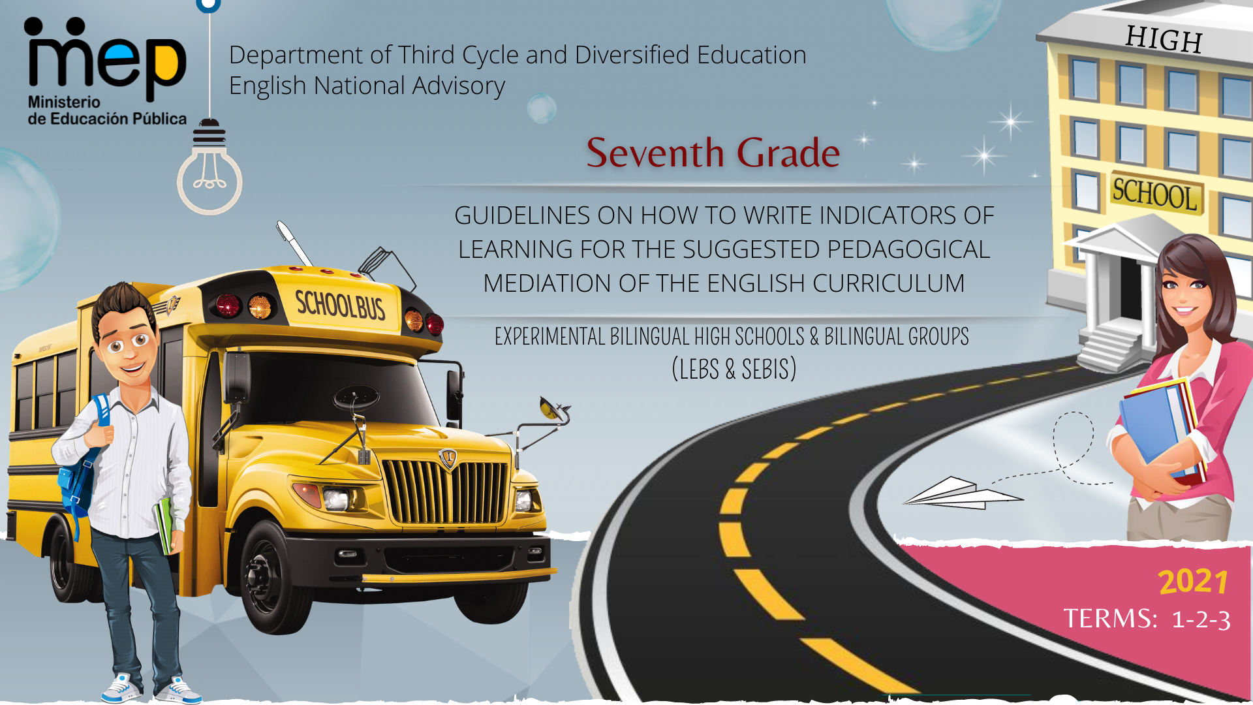

**Autoridades**

**Giselle Cruz Maduro**

Ministro de Educación Pública

**Melania Brenes Monge**

Viceministra Académica de Educación

**María Alexandra Ulate Espinoza**

Directora de la Dirección de Desarrollo Curricular

**Rigoberto Corrales Zúñiga**

Jefe del Departamento de Tercer Ciclo y Educación Diversificada

**Comisión redactora**

**Mag. Marianella Granados Sirias,**

Asesora Nacional de Inglés, Departamento de Tercer Ciclo y Educación Diversificada

**Mag. Alfredo Ortega Cordero**,

Asesor Nacional de Inglés, Departamento de Tercer Ciclo y Educación Diversificada

**Mag. Andrea Cruz Badilla**

Asesora Nacional de Inglés, Departamento de Tercer Ciclo y Educación Diversificada

**Sandra Araya Acuña**

Asesora Regional DRE Guápiles

**Max Arias Segura**

Asesor Regional DRE Liberia

**Livia Gamboa Cordero**

Asesora Regional DRE San Carlos

**Ezequiel Rojas Gutiérrez**

Asesor Regional DRE San José Central

**Diana Sanchún Orozco**

Asesora Regional DRE Nicoya

**Melissa González Castro**

Asesora Regional DRE San José Norte

**Comisión validadora**

Ivannia Arias Zúñiga. Sección Bilingüe Español-Inglés Liceo de Sinaí

Félix Díaz Castañeda, Sección Bilingüe Español-Inglés Liceo de Nicoya

Karen Pereira Meneses, Liceo de Costa Rica

Ana Lucía Ramírez Rodríguez, Liceo de Costa Rica

David Valerio Sánchez, Liceo de Costa Rica

Juliana Sánchez Sánchez, Sección Bilingüe Español-Inglés Liceo San Rafael

Roberto Segnini Cabezas, Sección Bilingüe Español-Inglés Liceo de Colorado

Luis Diego Soto Delgado, Sección Bilingüe Español-Inglés Liceo de Higuito

**Diseño de portada**

**Noelia González Cascante**

Dirección Regional de Educación Guápiles

**Table of Contents**

1. Presentation ……………………………………………………………………………………………………………………….…5
2. Aims of the document ……………………………………………………………………………………………………….….…..5
3. Important points to keep in mind when working with the indicators…………………………………………………………….6
4. Tasks and their relationship with indicators of learning ………………………………………………………………………….7
5. Indicators of Learning ………..............................................................................................................................................9
6. 7th Grade Indicators of Learning …………………………………………………………….……………………………………11
7. Indicators of Learning ………………..………………………………………………………………..…………………………...14
8. Indicators of Learning Term 1..…………………….…………………………………………………………………….……......15
9. Indicators of Learning Term 2 ……………………………………………………………………………………………..………31
10. Indicators of Learning Term 3 ……………………………………………………………………………………………..……...50
11. Sample Rubrics for Self-Study Guides ………………………………………………………….………………………...…...…67
12. Rubrics for Oral & Written Comprehension……………………………………………………..…………………….………….68
13. Rubrics for and Oral & Written Production…………………………………………………………………………...…………..76
14. Sample Rubrics and Performance Scale for Summative Assessment Instruments and the Assessment Promotion Strategy ………………………………………………………………………………………………………………………..…….77
15. References …………………………………………………………………………………………………………..………………83

**Presentation**

**Dear teachers:**

These guidelines intend to provide English teachers of seventh grade with important information on how effectively write indicators and create assessment instruments for their Self-Study Guides (GTA) and the assessment promotion strategy or *estrategia de promoción* in Spanish. It includes sample rubrics and performance scales for summative and formative assessment in oral and written comprehension and oral and written production. All the indicators and instruments will help teachers to measure the goals and the three learnings (Learn to Know, Learn to Do, Learn to Be and Live in Community) set in the new English curriculum when designing tasks. As a result, learners can achieve the expected level of performance in the target language according to the CEFR. We believe that you know your students best and therefore we encourage you **to adapt and contextualize** what you find here so that it responds to the needs of your learners. Remember to visit the following link https://recursos.mep.go.cr/lebs_y_sebi/:

**Aims of this document:**

1. To give teachers a brief explanation on how to write indicators of learning for planning their Self-Study Guides (GTA in Spanish).
2. To recommend a list of suggested indicators of learning per unit and linguistic competence according to the CEFR levels for Seventh Grade.
3. To offer some sample rubrics for the Self-Study Guides and sample rubrics and Performance Scales for Summative Assessment and Formative Assessment Instruments.

Best,

English Secondary National Advisors

**Important points to keep in mind when working with the indicators.**

The CEFR defines communication as a social act, where learners are social agents, developing a range of general and specific communicative language competences, moving from learning about the language to learning to communicate in the language in active, spontaneous, and authentic language interaction. Most of the tasks to be accomplished have a meaningful communication objective, for example, solving a problem in a given scenario.

The CEFR defines competences as “the sum of knowledge, skills and characteristics that allow a person to perform actions in society.” (p.9). They are comprised of general and specific competences as shown in the following graphic organizer. General competences consist of knowledge, skills, and abilities to learn and existential competence that are not language-specific, but learners use them when performing all kinds of actions including language activities.

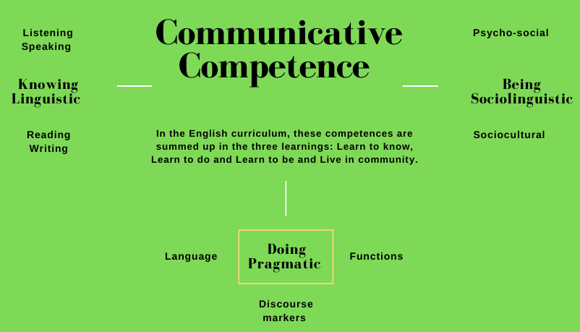

**Tasks and their relationship with indicators of learning**

When working with the Action–Oriented Approach (AOA), teachers need to design tasks that reflect the interests, abilities, and learning styles of their students for each linguistic competence or when integrating two of them. These tasks must have a variety of authentic texts and models of language (e.g., music, video clips, stories and news media). In regard to the indicators of learning, they are used to assess the tasks proposed during the pedagogical mediation process. Indicators of learning are strictly related to the task achievement, and they help to provide specific and timely descriptive feedback to students.

**What is a task?**

**What are the task features?**

|  |  |  |
| --- | --- | --- |
| Task features | | |
| Simple  (*Looking for special events in town*)  Complex  (*Planning a weekend with friends*) | Authentic situations  Individually and /or peers | When will this task happen in real life?  What is the task purpose?  What will be accomplished? |

**Task Sample**

**Simple Action- Oriented Task**

|  |  |  |
| --- | --- | --- |
| Authentic situation | | |
| **Assessment Strategy** | ***When would this task occur in real life?*** | ***What is the task purpose? What will be accomplished?*** |
| SI.1. asks and tells others his/her desires about shopping prices, size and where to get things. | Buying things at a convenience store. | Good morning! Can you help me? Where can I get a bottle of water? |

**Complex Action- Oriented Task**

|  |  |  |
| --- | --- | --- |
| Authentic situation | | |
| **Assessment Strategy** | ***When would this task occur in real life?*** | ***What is the task purpose? What will be accomplished?*** |
| SI.1. asks and tells others his/her desires about shopping prices, size and where to get things. | Buying things at a convenience store. | You are driving to Liberia city for a family vacation, and you stop for gas on the way. Go into a convenience store and buy supplies for the journey. Ask the sales assistant for help finding these items. Discuss price, quantity, payment options. |

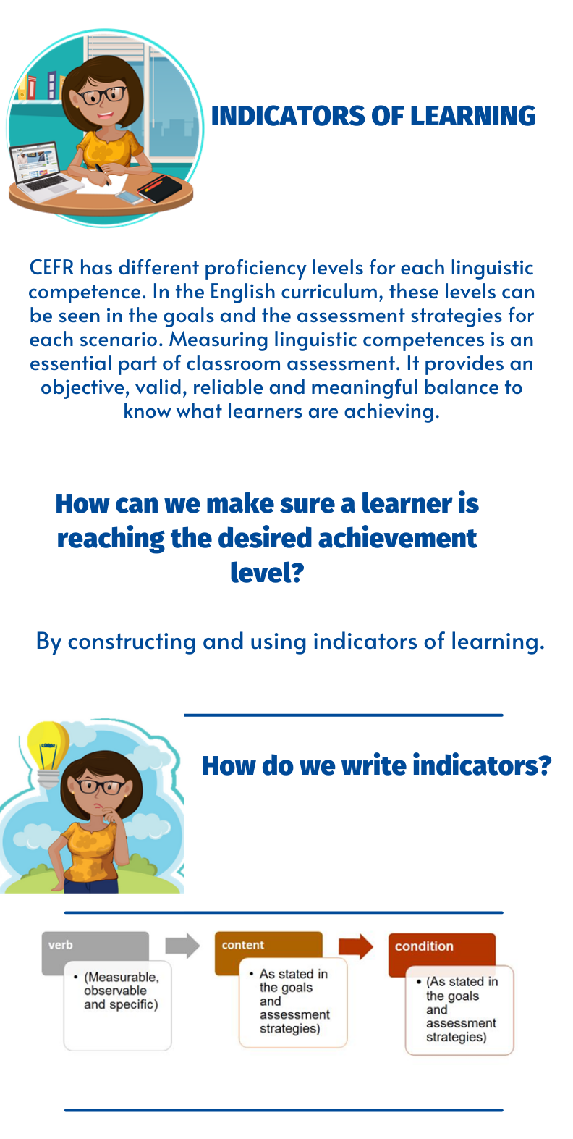

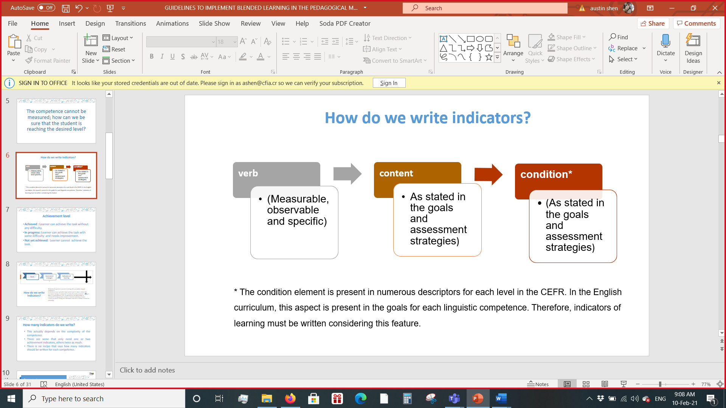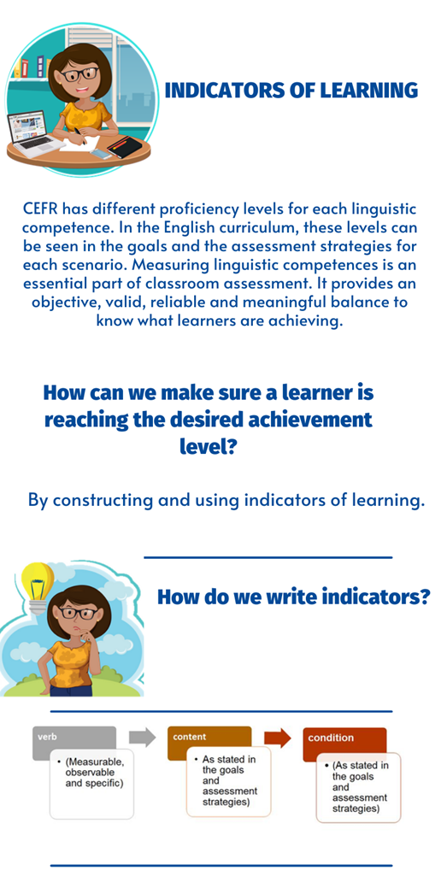

**\*** The condition element is present in numerous descriptors for each level in the CEFR. In the English curriculum, this aspect is present in the goals for each linguistic competence. Therefore, indicators of learning must be written considering this feature.

**.**

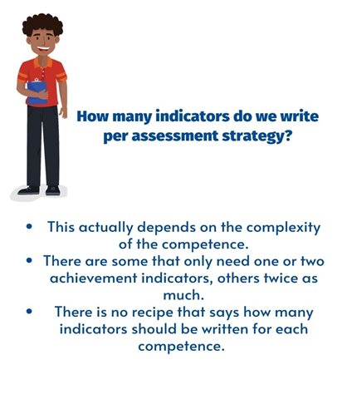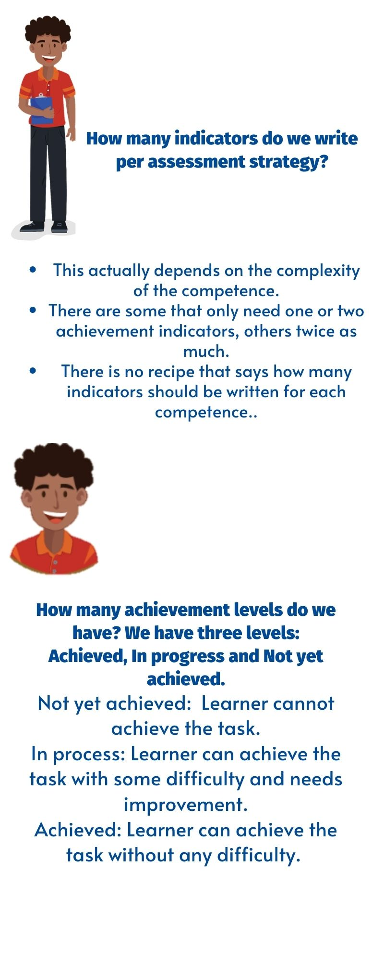

**7th Grade Indicators of Learning**

The 7th Grade curriculum and the teachers’ guide provide student-can-do descriptors called goals, accompanied by assessment strategies. These assessment strategies are evidence that a teacher can record to show that students are achieving the unit goals.

As classroom teachers, however, we do not simply assess students´ progress. We must guide students step by step through activities that enable them to reach their goals.

This document breaks each assessment strategy down into a number of indicators of learning. They are the steps that learners follow to achieve the goals. Indicators of learning have the following characteristics: measurable, observable and specific.

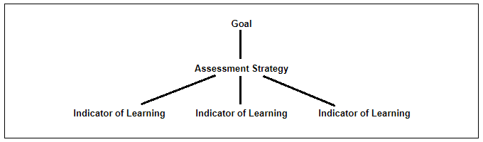

**How to use this document:**

1) Identify the goal and assessment strategy that you will be using. Remember, a goal is a can- do performance descriptor while an assessment strategy provides evidence of learner’s learning outcomes.

2) Consider the steps or indicators learners need to follow to achieve each assessment strategy. It is important to clarify that each assessment strategy is linked to a goal. See the example below:

|  |  |  |
| --- | --- | --- |
| **Goal** | **Assessment Strategy** | **Indicators of Learning** |
| **L.2.** Understand classroom language. | **L.2.** discriminates classroom language within oral utterances. | L2.1 Gets the gist of short conversations related to classroom language.  L2.2 Distinguish basic classroom expressions related to classroom language, from aural/oral stimulus. |

3) Find the unit and assessment strategy in this document and consult the list of indicators of learning to check your own work.

4) While teaching (Oral Comprehension, Written Comprehension, Oral Production, Written Production), guide students to accomplish each of the indicators of learning along the way to achieving the goals and assessment strategies. Remember that there should be a connection between the assessment strategies, indicators of learning, and pedagogical mediation for each competence.

5) Use indicators of learning throughout each unit to monitor students’ progress and make the corresponding mediation changes if necessary.

**Important considerations:**

1. Indicators of learning are organized by unit, then by assessment strategy.
2. It is important to take into account the corresponding level of difficulty of the assessment strategy when writing the indicators.
3. In some of the indicators proposed, teachers have to include the content of those indicators. To do that, they will complete the idea after the word “about”. For example: “Identifies facts in clearly drafted print materials about leisure activities”.
4. In most of the cases, the indicators of learning for each assessment strategy are arranged in a suggested order for students to perform them appropriately.
5. It is always necessary to use an indicator of learning, such as the one suggested in this document. As educators, teachers must use their own professional judgement to identify the steps their students most need to take to achieve the learning goals and that is reflected in the pedagogical mediation.
6. During the face- to- face and/or distance pedagogical mediation process, and therefore, at the end of each self-study guide, the teacher will use the indicators of learning to create instruments (rubrics and /or performance scales) to assess students’ achievement level.
7. The mediation activities in the self-study guides must be coherent with the indicators of learning to be included in the corresponding achievement rubric.
8. Remember that the Pre-teaching Stage **must not** consider indicators of learning. They are strictly related to the suggested mediation sequence for each linguistic competence. Not every step of the suggested mediation in the self-study guides/didactic planning must have indicators, only the ones that are necessary to achieve the corresponding assessment strategy and learning goal for each linguistic competence.
9. Most of the tasks suggested in the teacher´s guide match the indicators of learning because they follow the mediation proposed for each competence. If you use the tasks proposed in the teacher’s guide for planning your self -study guides, make sure these tasks match with the steps proposed to mediate each competence and consequently the self-assessment section.
10. When revising the activities in the teacher’s guide or any other resource to plan your lessons, consider that you can follow the steps below as suggested by the Institute of Collaborative Learning:

* **S**elect the activity and leave it as it is.
* **A**dapt it or change it somehow.
* **R**eject it. Choose not to use it
* **S**upplement it. Enrich the activity with extra material to make it more appropriate.

Assessment Strategies & Indicators of Learning

| Level: 7th  Term: 1  CEFR Band: A.1.1  Scenario: Let´s Meet and Greet  Oral Comprehension & Oral Production | | |
| --- | --- | --- |
| Assessment Strategies | Indicators of Learning | |
| L.1. identifies basic greetings, farewells, common expressions of politeness (e.g., hello, goodbye, sorry) and personal information. | L.1.1 | Gets the gist of an aural/oral stimulus. |
| L.1.2 | Identifies basic greetings from an aural/oral stimulus. |
| L.1.3 | Identifies basic farewells from aural/oral stimulus. |
| L.1.4 | Identifies common expressions of politeness from aural/oral stimulus. |
| L.1.5 | Identifies personal information from aural/oral stimulus. |
| L.2. identifies messages by making predictions using prior knowledge and contextual clues. | L.2.1 | Gets main ideas from messages using prior knowledge and contextual clues. |
| L.2.2 | Identifies messages using prior knowledge and contextual clues to make predictions. |
| L.3. recognizes familiar words and very basic phrases concerning his/her family, everyday activities, when people speak slowly, clearly and with significant pauses | L.3.1 | Identifies the topic of an aural/oral stimulus. |
| L.3.2 | Relates familiar words and very basic phrases concerning his/her family with their definitions, meanings or images when people speak slowly, clearly and with significant pauses. |
| L.3.3 | Recognizes familiar words and very basic phrases concerning everyday activities w when people speak slowly, clearly and with significant pauses. |
| L.4. recognizes simple information such as name, age, and perhaps country of origin, when that information is given slowly and clearly. | L.4.1 | Gets main ideas from audios, videos or read-alouds when that information is given slowly and clearly. |
| L.4.2 | Identifies key words related to personal information when that information is given slowly and clearly. |
| L.4.3 | Recognizes simple information in audios, videos or read-alouds, such as name, age, and perhaps country of origin, when that information is given slowly and clearly. |
| L.5. recognizes others’ expressions of feelings. | L.5.1 | Gets the mood of conversations, videos, presentations, audios or read-alouds. |
| L.5.2 | Identifies emotions/feelings being experienced by others. |
| L.5.3 | Recognizes feelings/emotions through facial expressions and tone of voice in videos or read-alouds. |
| L.6. recognizes everyday expressions in different audio texts dealing with simple and concrete familiar topics, in clear, slow, repeated speech and with significant pauses. | L.6.1 | Gets the gist of everyday expressions dealing with simple and concrete familiar topics, in clear, slow, repeated speech and with significant pauses. |
| L.6.2 | Relates everyday expressions with their meanings or images dealing with simple and concrete familiar topics, in clear, slow, repeated speech and with significant pauses. |
| L.6.3 | Recognizes everyday expressions in different audio texts dealing with simple and concrete familiar topics, in clear, slow, repeated speech and with significant pauses. |
| L.7. recognizes questions and short, simple classroom instructions. | L.7.1 | Grasps the main idea of questions and short, simple classroom instructions. |
| L.7.2 | Recognizes questions from an aural/oral stimulus. |
| L.7.3 | Recognizes short, simple classroom instructions. |
| L.7.4 | Follows short, simple classroom instructions. |
| SI.1. uses basic expressions of greeting, farewell, leave-takings and politeness. | SI.1.1 | Plans a set of basic expressions of greeting, farewell, leave-takings and politeness. |
| SI.1.2 | Makes complete sentences using basic expressions of greeting, farewell, leave-takings and politeness. |
| SI.1.3 | Uses basic expressions of greetings in the form of words or phrases to introduce oneself or to greet others in different types of interaction. |
| SI.1.4 | Uses basic expressions of farewells to give good wishes on parting in different types of interaction. |
| SI.1.5 | Uses basic expressions of leaving- takings in the form of words or phrases to say good-bye in different types of interaction. |
| SI.1.6 | Uses basic expressions of politeness in different types of interaction. |
| SI.2. makes introductions of self and others. | SI.2.1 | Plans the language and content to make introductions of self and others. |
| SI.2.2 | Makes complete sentences telling his/her name (who he/she is), occupation (what he/she does) and some facts to create a nice impression (what others need to know about him/her). |
| SI.2.3 | Makes self-introductions telling his/her name (who he/she is), occupation (what he/she does) and some facts to create a nice impression (what others need to know about him/her). |
| SI.2.4 | Introduces others telling his/her name (who he/she is), occupation (what he/she does) and some facts to create a nice impression (what others need to know about him/her). |
| SI.3. communicates the day, date, and time, as well as ask about those matters. | SI.3.1 | Plans the language and content to communicate the day, date, and time, as well as ask about those matters. |
| SI.3.2 | Makes complete sentences to communicate the day, date, and time, as well as ask about those matters. |
| SI.3.3 | Tells someone the day, date and time in different types of interactions. |
| SI.3.4 | Asks someone the day, date and time in different types of interactions. |
| SI.4 asks and answers simple questions about familiar things, if the other person speaks slowly and clearly. | SI.4.1 | Plans the language and content to ask and answer simple questions about familiar things, if the other person speaks slowly and clearly. |
| SI.4.2 | Makes sentences to ask and answer simple questions about familiar things, if the other person speaks slowly and clearly. |
| SI.4.3 | Asks simple yes/no and wh- questions about familiar things, if the other person speaks slowly and clearly. |
| SI.4.4 | Answers simple questions about familiar things, if the other person speaks slowly and clearly. |
| SI.5. expresses lack of understanding using body language or formulaic expressions. | SI.5.1 | Plans a set of formulaic expressions and body language that express lack of understanding. |
| SI.5.2 | Makes lists of formulaic expressions to show lack of understanding. |
| SI.5.3 | Uses survival and body language to express lack of understanding. Ex. I don´t understand. Can you repeat again, please? |
| SI.5.4 | Asks someone to say something more clearly, to explain something a different way, or to repeat what has been said. |
| SI.6 expresses simple needs in the classroom setting. | SI.6.1 | Plans a set of formulaic expressions, phrases or single words to express simple needs in the classroom setting. |
| SI.6.2 | Makes lists of formulaic expressions, phrases or single words to express simple needs in the classroom setting. |
| SI.6.3 | Uses survival language to express simple needs in the classroom setting. |
| SI.6.4 | Uses formulaic expressions, phrases or single words to ask for permission, repetition, clarification or assistance. |
| SI.7. expresses a sequence of events or actions by placing them in some sort of order. | SI.7.1 | Plans the language and content used to sequence events or actions. |
| SI.7.2 | Organizes information and ideas to sequence events or actions in graphic organizers, timelines or outlines. |
| SI.7.3 | Tells a sequence of events or actions by placing them in some sort of order**.** |
| SI.8. uses common, familiar everyday expressions to meet specific practical needs. | SI.8.1 | Plans a set of common, familiar everyday expressions to meet specific practical needs. |
| SI.8.2 | Makes lists of common, familiar everyday expressions to meet specific practical needs. |
| SI.8.3 | Uses common, familiar everyday expressions to meet specific practical needs in different kinds of interaction. |
| SI.9. uses simple statements related to daily/weekend routines. | SI.9.1 | Plans a set of expressions, phrases and single words related to daily/weekend routines. |
| SI.9.2 | Makes lists of simple statements and vocabulary related to daily/weekend routines. |
| SI.9.3 | Uses simple statements related to daily/weekend routines in different kinds of interaction. |
| SI.10. interacts in a simple way with others repeating or rephrasing ideas at a slower rate of speech. | SI.10.1 | Plans a set of expressions, phrases and single words to repeat or rephrase ideas at a slower rate of speech in simple interactions. |
| SI.10.2 | Makes lists of expressions, phrases and single words used to repeat or rephrase ideas at a slower rate of speech in simple interactions. |
| SI.10.3 | Repeats ideas at a slower rate of speech in simple interactions. |
| SI.10.4 | Rephrases ideas at a slower rate of speech in simple interactions. |
| SI.11. interacts in simple phone conversations. | SI.11.1 | Plans the language and content to interact in simple phone conversations. |
| SI.11.2 | Makes lists of expressions, phrases and single words used to interact in simple phone conversations. |
| SI.11.3 | Asks questions over the phone to family or friends. |
| SI.11.4 | Answers questions over the phone to family or friends |
| SP.1 talks about himself/herself very briefly, for example stating name, where s/he is from, and what school s/he attends, including information about his/her family. | SP.1.1 | Plans the language, content and visuals to talk about himself/herself very briefly, for example stating name, where s/he is from, and what school s/he attends, including information about his/her family. |
| SP.1.2 | Organizes information, ideas and visuals in graphic organizers, outlines or lists to talk about himself/herself very briefly, for example stating name, where s/he is from, and what school s/he attends, including information about his/her family. |
| SP.1.3 | Makes sentences with the information using the appropriate linkers or connecting words to talk about himself/herself very briefly, for example stating name, where s/he is from, and what school s/he attends, including information about his/her family. |
| SP.1.4 | Talks about himself/herself very briefly, for example stating name, where s/he is from, and what school s/he attends, including information about his/her family. |
| SP.2 describes his/her daily and weekend routines to the class using simple phrases and formulaic expressions. | SP.2.1 | Plans the language, content and visuals to describe his/her daily and weekend routines to the class using simple phrases and formulaic expressions. |
| SP.2.2 | Makes lists of simple phrases, formulaic expressions and visuals to describe his/her daily and weekend routines to the class. |
| SP.2.3 | Makes sentences with the information using the appropriate linkers or connecting words to describe his/her daily and weekend routines to the class. |
| SP.2.4 | Describes his/her daily and weekend routines to the class using simple phrases and formulaic expressions. |
| SP.3 describes familiar topics using simple phrases. | SP.3.1 | Plans the language, content and visuals to describe familiar topics using simple phrases. |
| SP.3.2 | Makes lists of simple phrases, ideas and visuals to describe familiar topics. |
| SP.3.3 | Makes sentences with the information using the appropriate linkers or connecting words to describe familiar topics using simple phrases. |
| SP.3.4 | Describes familiar topics using simple phrases. |
| SP.4 recounts recent experiences and gives compliments. | SP.4.1 | Plans the language, content and visuals to recount recent experiences and gives compliments. |
| SP.4.2 | Organizes information, ideas and visuals in graphic organizers, outlines or lists torecount recent experiences and gives compliments. |
| SP.4.3 | Makes sentences with the information using the appropriate linkers or connecting words to recount recent experiences and gives compliments. |
| SP.4.4 | Recounts recent experiences. |
| SP.4.5 | Gives compliments. |

Propuesta elaborada por: **Sandra Araya Acuña, Asesora Regional de Inglés, DRE Guápiles.** Revisado porMarianella Granados Sirias, Alfredo Ortega Cordero, Andrea Cruz Badilla. Asesores Nacionales de Inglés. **Departamento de Tercer Ciclo y Educación Diversificada. Dirección de Desarrollo Curricular**

| Level: 7th  Term: 1  CEFR Band: A.1.1  Scenario: Let´s Meet and Greet  Written Comprehension & Written Production | | | |
| --- | --- | --- | --- |
| Assessment Strategies | | Indicators of Learning | |
| R.1. identifies messages, making predictions using prior knowledge, contextual and typographical clues, titles, labels, headings, headlines, pictures, illustrations, visuals, key words and sequence of events. | | R.1.1 | Gets the gist of messages to make predictions using prior knowledge, contextual and typographical clues, titles, labels, headings, headlines, pictures, illustrations, visuals, key words and sequence of events. |
| R.1.2 | Gets specific details in messages to make predictions using prior knowledge, contextual and typographical clues, titles, labels, headings, headlines, pictures, illustrations, visuals, key words and sequence of events. |
| R.1.3 | Identifies messages to make predictions using prior knowledge, contextual and typographical clues, titles, labels, headings, headlines, pictures, illustrations, visuals, key words and sequence of events. |
| R.2. identifies brief, simple classroom signs, appropriate pieces of vocabulary and familiar expressions and other clear-cut instructions if there are pictures or diagrams to illustrate the most important steps or if the procedure has been previously demonstrated. | | R.2.1 | Gets the gist of brief, simple classroom, signs appropriate pieces of vocabulary and familiar expressions and other clear-cut instructions if there are pictures or diagrams to illustrate the most important steps or if the procedure has been previously demonstrated. |
| R.2.2 | Relates brief, simple classroom signs, appropriate pieces of vocabulary and familiar expressions and other clear-cut instructions with their corresponding meaning if there are pictures or diagrams to illustrate the most important steps or if the procedure has been previously demonstrated. |
| R.2.3 | Labels pictures with brief, simple classroom, signs appropriate pieces of vocabulary and familiar expressions and other clear-cut instructions. |
| R.2.4 | Identifiesbrief, simple classroom signs if there are pictures or diagrams to illustrate the most important steps or if the procedure has been previously demonstrated. |
| R.2.5 | Identifiesappropriate pieces of vocabulary and familiar expressions if there are pictures or diagrams to illustrate the most important steps or if the procedure has been previously demonstrated. |
| R.2.6 | Identifiesclear-cut instructions if there are pictures or diagrams to illustrate the most important steps or if the procedure has been previously demonstrated. |
| R.3. identifies English language sounds using knowledge in phonics, syllabification and word parts. | | R.3.1 | Recognizes sounds in words. |
| R.3.2 | Articulates the sounds. |
| R.3.3 | Produces sentences in an oral or written form. |
| R.4. recognizes some words and straightforward sentences in simple texts, if seen previously. | | R.4.1 | Previews simple texts by looking at headings, subheadings, pictures, diagrams, etc. |
| R.4.2 | Relates words and straightforward sentences in simple texts with meaning or images. |
| R.4.3 | Identifies some words and straightforward sentences that are the most important in simple texts. |
| R.4.4 | Recognizes some words and straightforward sentences in simple texts, if seen previously. |
| R.5. recognizes straightforward forms in order to insert personal information. | | R.5.1 | Identifies the topic of straightforward forms. |
| R.5.2 | Identifies key word or specific information in straightforward forms to insert personal information. |
| R.5.3 | Inserts personal information in straightforward forms. |
| R.6. recognizes simple short messages and greetings. | | R.6.1 | Gets the gist of simple short messages and greetings. |
| R.6.2 | Relatessimple short messages with their corresponding meaning or image. |
| R.6.3 | Relates greetings with their corresponding meaning or image. |
| R.6.4 | Recognizes simple short messages and greetings in different kinds of text. |
| R.7. recognizes numbers in meaningful contexts. | | R.7.1 | Skims the text by looking at numbers. |
| R.7.2 | Recognizes numbers in meaningful contexts when giving personal information (age, address, telephone number, date, time) in forms, questionnaires, schedules and others. |
| R.7.3 | Uses numbers when giving personal information (age, address, telephone number, date, time) in forms, questionnaires, schedules and others. |
| R.8. recognizes the general idea, familiar names, words, and very simple sentences and paragraphs, containing pictures when reading simple, short texts slowly. | | R.8.1 | Recognizes the general idea when reading simple, short texts slowly and supported by pictures. |
| R.8.2 | Recognizes words when reading simple, short texts slowly and supported by pictures. |
| R.8.3 | Recognizes familiar names when reading simple, short texts slowly and supported by pictures. |
| R.8.4 | Recognizes specific information in simple sentences and paragraphs when reading simple, short texts slowly and supported by pictures. |
| W.1. writes words on familiar objects in a picture or diagram (e.g., boy, girl, chair). | | W.1.1 | Labels familiar objects in pictures (e.g., boy, girl, chair). |
| W.1.2 | Writes words on familiar objects in diagrams (e.g., boy, girl, chair). |
| W.2. writes words or phrases on registration forms and questionnaires with personal details. | | W.2.1 | Brainstorms vocabulary or phrases needed to fill in registration forms or questionnaires. |
| W.2.2 | Completes registration forms and questionnaires with personal details using words or phrases. |
| W.2.3 | Revises there isn´t any field left blank in registration forms and questionnaires. |
| W.2.4 | Fills in missing blanks before publishing it. |
| W.3. writes simple phrases and sentences. | | W.3.1 | Prewrites a list of vocabulary to be used in simple phrases and sentences. |
| W.3.2 | Drafts simple phrases and sentences. |
| W.3.3 | Revises simple phrases and sentences to look for mistakes related to subject-verb Agreement, capitalization, spelling, and basic punctuation and content. |
| W.3.4 | Edits simple phrases and sentences by correcting the mistakes before publishing them. |
| W.4. writes simple sentences with assistance, using a dictionary or textbook | | W.4.1 | Prewrites a list of vocabulary to be used in simple sentences using a dictionary or textbook. |
| W.4.2 | Drafts simple sentences using a dictionary or textbook. |
| W.4.3 | Revises simple sentences to look for mistakes related to subject-verb agreement, capitalization, spelling, and basic punctuation and content. |
| W.4.4 | Edits simple sentences by correcting the mistakes before publishing them. |
| W.5. writes simple information about himself/herself (e.g., name, age, address). | | W.5.1 | Brainstorms ideas about him/herself. (e.g., name, age, address). |
| W.5.2 | Drafts sentences about him/herself by using sentence frames and the appropriate linkers or connecting words. |
| W.5.3 | Revises the sentences to look for mistakes related to subject-verb  Agreement, capitalization, spelling, and basic punctuation) and content. |
| W.5.4 | Edits the sentences by correcting the mistakes before publishing them. |
| W.6. writes brief messages like birthday, holiday greetings, invitations, postcards, a tweet, and notes to friends. | **A. Birthday wishes to a friend.** | W.6.1.A | Prewrites brief messages like birthday wishes to friends. |
| W.6.2.A | Drafts brief messages like birthday wishes to friends. |
| W.6.3.A | Revises brief messages like birthday wishes to friends to look for mistakes related to subject-verb agreement, capitalization, spelling, and basic punctuation and content. |
| W.6.4.A | Edits brief messages like birthday wishes to friends by correcting the mistakes before publishing them. |
| **B. Holiday greetings to a friend.** | W.6.1.B | Prewrites brief messages like holidays greetings to friends. |
| W.6.2.B | Drafts brief messages like holiday greetings to friends. |
| W.6.3.B | Revises brief messages like holiday greetings to friends to look for mistakes related to subject-verb agreement, capitalization, spelling, and basic punctuation and content. |
| W.6.4.B | Edits brief messages like holiday greetings to friends by correcting the mistakes before publishing them. |
| **C. Invitations to a friend.** | W.6.1.C | Prewrites brief messages like invitations to friends. |
| W.6.2.C | Drafts brief messages like invitations to friends. |
| W.6.3.C | Revises brief messages like invitations to friends to look for mistakes related to subject-verb agreement, capitalization, spelling, and basic punctuation and content. |
| W.6.4.C | Edits brief messages like invitations to friends by correcting the mistakes before publishing them. |
| **D. Postcards to a friend.** | W.6.1.D | Prewrites brief messages like postcards to friends. |
| W.6.2.D | Drafts brief messages like postcards to friends. |
| W.6.3.D | Revises brief messages like postcards to friends to look for mistakes related to subject-verb agreement, capitalization, spelling, and basic punctuation and content. |
| W.6.4.D | Edits brief messages like postcards to friends by correcting the mistakes before publishing them. |
| **E. Tweet to a friend.** | W.6.1.E | Prewrites brief messages like a tweet to friends. |
| W.6.2.E | Drafts brief messages like a tweet to friends. |
| W.6.3.E | Revises brief messages like a tweet to friends to look for mistakes related to subject-verb agreement, capitalization, spelling, and basic punctuation and content. |
| W.6.4.E | Edits brief messages like notes to friends by correcting the mistakes before publishing them. |
| **F. Notes to a friend.** | W.6.1.F | Prewrites brief messages like notes to friends. |
| W.6.2.F | Drafts brief messages like notes to friends. |
| W.6.3.F | Revises brief messages like notes to friends to look for mistakes related to subject-verb agreement, capitalization, spelling, and basic punctuation and content. |
| W.6.4.F | Edits brief messages like notes to friends by correcting the mistakes before publishing them. |

Propuesta elaborada por: **Sandra Araya Acuña, Asesora Regional de Inglés, DRE Guápiles.** Revisado porMarianella Granados Sirias, Alfredo Ortega Cordero, Andrea Cruz Badilla. Asesores Nacionales de Inglés. **Departamento de Tercer Ciclo y Educación Diversificada. Dirección de Desarrollo Curricular**

| Level: 7th  Term: 2  CEFR Band: A1.2  Scenario: Hanging Out in my Community  Oral Comprehension & Oral Production | | |
| --- | --- | --- |
| Assessment Strategies | Indicators of Learning | |
| L.1. follows instructions and short simple directions. (e.g., on the second floor, near the bus stop, third door on the left). | L.1.1 | Gets the gist of Instructions and short simple directions. |
| L.1.2 | Recognizes short simple words in instructions to follow directions. |
| L.1.4 | Recognizes short simple phrases to follow directions |
| L.1.5 | Follows instructions and short simple directions. |
| L.2. recognizes basic phrases that denote position (under, over, beside) | L.2.1 | Gets the gist of an aural/oral stimulus. |
| L.2.2 | Identifies key words that denote position ( under, over, beside) |
| L.2.3 | Recognizes basic phrases that denote position (under, over, beside) |
| L.3. recognizes simple information about places, if the speaker speaks slowly and clearly, possibly with accompanying gestures. | L.3.1 | Gets main ideas from audios, videos or read-alouds when that information is given slowly and clearly, possibly with accompanying gestures. |
| L.3.2 | Identifies key words related to places when that information is given slowly and clearly, possibly with accompanying gestures. |
| L.3.3 | Recognizes simple information in audios, videos or read-alouds about places, if the speaker speaks slowly and clearly, possibly with accompanying gestures. |
| L.4. recognizes familiar words, names, numbers in prices and times, previously learned when heard in a short, simple recording delivered at a slow pace. | L.4.1 | Identifies the topic when heard in a short, simple recording delivered at a slow pace. |
| L.4.2 | Recognizes familiar words when heard in a short, simple recording delivered at a slow pace. |
| L.4.3 | Recognizes names when heard in a short, simple recording delivered at a slow pace. |
| L.4.4 | Recognizes numbers in prices and times when heard in a short, simple recording delivered at a slow pace. |
| L.5. identifies the sound of most letters heard in context. | L.5.1 | Identifies the topic of an aural/oral stimulus. |
| L.5.2 | Identifies the sound of most letters heard in context |
| L.6. identifies details, sequence of events, differences, similarities, causes and effects in short conversations. | L.6.1 | Gets main ideas from short conversations. |
| L.6.2 | Identifies specific details in short conversations. |
| L.6.3 | Identifies sequence of events in short conversations. |
| L.6.4 | Identifies similarities and differences in short conversations. |
| L.6.5 | Identifies causes and effects in short conversations. |
| L.7. make predictions by using prior knowledge and contextual clues. | L.7.1 | Gets main ideas from messages using prior knowledge and contextual clues. |
| L.7.2 | Gets specific details from messages using prior knowledge and contextual clues. |
| L.7.3 | Makes predictions using prior knowledge and contextual clues. |
| L.8. recognizes everyday expressions dealing with simple and concrete everyday needs, in clear, slow and repeated speech. | L.8.1 | Gets the gist of everyday expressions dealing with simple and concrete everyday needs in clear, slow, repeated speech. |
| L.8.2 | Relates everyday expressions with their meanings or images dealing with simple and concrete everyday needs in clear, slow, repeated speech. |
| L.8.3 | Recognizes everyday expressions in different audio texts dealing with simple and everyday needs in clear, slow, repeated speech. |
| L.9. interprets basic information from a variety of sources of topics related to fun favorites, fun places around town, locations and times, and free activities for fun. | L.9.1 | Makes predictions by looking at pictures before listening to an audio. |
| L.9.2 | Gets main ideas from audios related to fun favorites, fun places around town, locations and times, and free activities for fun. |
| L.9.3 | Gets supporting ideas and specific details from audios related to fun favorites, fun places around town, locations and times, and free activities for fun. |
| L.9.4 | Identifies author’s argument from audios related to fun favorites, fun places around town, locations and times, and free activities for fun. |
| L.9.5 | Organizes information in a hierarchy (themes, main ideas, supporting ideas, and supporting details) using mapping, webbing or charting. |
| L.9.6 | Recalls what was said in audios related to fun favorites, fun places around town, locations and times, and free activities for fun. |
| L.9.7 | Interprets most of what was said in audios related to fun favorites, fun places around town, locations and times, and free activities for fun using key ideas from the visualization- map. |
| L.10. infers situations, participants and goals using real world knowledge. | L.10.1 | Gets the gist of an aural/oral stimulus using real world knowledge. |
| L.10.2 | Identifies facts about situations, participants and goals using real world knowledge. |
| L.10.3 | Deduces information from evidences found in situations, participants and goals using real world knowledge. |
| |  | | --- | | SI.1. uses basic expressions of greeting, farewell, leave-takings and politeness (e.g. hello, goodbye, pleases, and thank you). | | SI.1.1 | Plans a set of basic expressions of greeting, farewell, leave-takings and politeness. |
| SI.1.2 | Makes complete sentences using basic expressions of greeting, farewell, leave-takings and politeness. |
| SI.1.3 | Uses basic expressions of greetings in the form of words or phrases to introduce oneself or to greet others in different types of interaction. |
| SI.1.4 | Uses basic expressions of farewells to give good wishes on parting in different types of interaction. |
| SI.1.5 | Uses basic expressions of leaving- takings in the form of words or phrases to say good-bye in different types of interaction. |
| SI.1.6 | Uses basic expressions of politeness in different types of interaction. |
| SI.2. makes introductions of self and others. | SI.2.1 | Makes a list of vocabulary and expressions to self-introduce and others. |
| SI.2.2 | Makes sentences using vocabulary and expressions to self-introduce and others according to social situations. |
| SI.2.3 | Makes self- introductions according to social situations. |
| SI.2.4 | Makes introductions of others according to social situations. |
| SI.3. communicates the day, date, and time, as well as ask about those matters. | SI.3.1 | Plans the language and content to communicate the day, date, and time, as well as ask about those matters. |
| SI.3.2 | Makes complete sentences to communicate the day, date, and time, as well as ask about those matters. |
| SI.3.3 | Tells someone the day, date and time in different types of interactions. |
| SI.3.4 | Asks someone the day, date and time in different types of interactions. |
| SI.4 asks and answers simple questions about different activities, directions, prices, schedules), if the other person speaks slowly and clearly. | SI.4.1 | Plans the language and content to ask and answer simple questions about different activities, directions, prices, schedules), if the other person speaks slowly and clearly. |
| SI.4.2 | Makes sentences to ask and answer simple questions about different activities, directions, prices, schedules), if the other person speaks slowly and clearly. |
| SI.4.3 | Asks simple yes/no and wh- questions about different activities, directions, prices, schedules), if the other person speaks slowly and clearly. |
| SI.4.4 | Answers simple questions about different activities, directions, prices, schedules), if the other person speaks slowly and clearly. |
| |  | | --- | | SI.5. expresses a lack of understanding using body language or formulaic expressions. | | SI.5.1 | Plans a set of formulaic expressions and body language that express lack of understanding. |
| SI.5.2 | Makes lists of formulaic expressions to show lack of understanding. |
| SI.5.3 | Uses survival and body language to express lack of understanding. Ex. I don´t understand. Can you repeat again, please? |
| SI.5.4 | Asks someone to say something more clearly, to explain something a different way, or to repeat what has been said. |
| SI.6. interacts in a simple way with others repeating or rephrasing ideas at a slower rate of speech. | SI.6.1 | Plans a set of expressions, phrases and single words to repeat or rephrase ideas at a slower rate of speech in simple interactions. |
| SI.6.2 | Makes lists of expressions, phrases and single words used to repeat or rephrase ideas at a slower rate of speech in simple interactions. |
| SI.6.3 | Repeats ideas at a slower rate of speech in simple interactions. |
| SI.6.4 | Rephrases ideas at a slower rate of speech in simple interactions. |
| SI.7. uses common, familiar everyday expressions to meet specific practical needs in community setting, e.g. asking for assistance with maps, directions, money times, schedules, timetables. | SI.7.1 | Brainstorms everyday expressions to meet specific practical needs in community setting in order to ask for assistance with maps, directions, money times, schedules, timetables. |
| SI.7.2 | Makes sentences using familiar everyday expressions to meet specific practical needs in community setting, e.g. asking for assistance with maps, directions, money times, schedules, timetables. |
| SI.7.3 | Uses common, familiar everyday expressions to meet specific practical needs in community setting in order to ask for assistance with maps, directions, money times, schedules, timetables. |
| SI.8. uses simple statements related to daily/ weekend routines. | SI.8.1 | Plans a set of expressions, phrases and single words related to daily/weekend routines. |
| SI.8.2 | Makes lists of simple statements and vocabulary related to daily/weekend routines. |
| SI.8.3 | Uses simple statements related to daily/weekend routines in different kinds of interaction. |
| SI.9. expresses a sequence of events or actions by placing them in some sort of order. | SI.9.1 | Plans the language and content used to sequence events or actions. |
| SI.9.2 | Organizes information and ideas to sequence events or actions in graphic organizers, timelines or outlines. |
| SI.9.3 | Tells a sequence of events or actions by placing them in some sort of order**.** |
| SI.10. interacts in simple phone conversations. | SI.10.1 | Plans the language and content to interact in simple phone conversations. |
| SI.10.2 | Makes lists of expressions, phrases and single words used to interact in simple phone conversations. |
| SI.10.3 | Asks questions over the phone to family or friends. |
| SI.10.4 | Answers questions over the phone to family or friends |
| SP.1. uses simple phrases to describe familiar topics such as likes and dislikes, a person, an object, clothes or a place, what he/she can or cannot do, and what other people or animals can or cannot do. | SP.1.1 | Brainstorms simple phrases to describe familiar topics such as likes and dislikes, a person, an object, clothes or a place, what he/she can or cannot do, and what other people or animals can or cannot do. |
| SP.1.2 | Makes sentences using simple phrases to describe familiar topics such as likes and dislikes, a person, an object, clothes or a place, what he/she can or cannot do, and what other people or animals can or cannot do. |
| SP.1.3 | Uses simple phrases to describe familiar topics such as likes and dislikes, a person, an object, clothes or a place, what he/she can or cannot do, and what other people or animals can or cannot do. |
| SP.2. responds to simple texts of instructions, descriptions or other types of information using elementary language. | SP.2.1 | Plans the language to respond to simple texts of instructions, descriptions or other types of information using elementary language. |
| SP.2.2 | Makes sentences to respond to simple texts of instructions, descriptions or other types of information using elementary language. |
| SP.2.3 | Responds to simple texts of instructions, descriptions or other types of information using elementary language. |
| SP.3. expresses how they are feeling using simple, standard expressions. | SP.3.1 | Brainstorms vocabulary used to express feelings. |
| SP.3.2 | Makes sentences to express how they are feeling using simple, standard expressions |
| SP.3.3 | Expresses how they are feeling using simple, standard expressions |
| SP.4. provides basic information about familiar things, different activities, directions, prices, schedules. | SP.4.1 | Brainstorms vocabulary and expressions used to give information about activities, directions, prices, schedules. |
| SP.4.2 | Makes sentences to provide basic information about familiar things, different activities, directions, prices, schedules. |
| SP.4.3 | Provides basic information about familiar things. |
| SP.4.4 | Provides basic information about different activities. |
| SP.4.5 | Provides basic information about directions. |
| SP.4.6 | Provides basic information about prices. |
| SP.4.7 | Provides basic information about schedules. |
| SP.5. produces some spoken texts such as role-plays, interviews, and oral presentations, recounting recent experiences and giving compliments. | SP.5.1 | Plans the language, content and visuals to recount recent experiences and gives compliments. |
| SP.5.2 | Organizes information, ideas and visuals in graphic organizers, outlines or lists torecount recent experiences and gives compliments. |
| SP.5.3 | Makes sentences with the information using the appropriate linkers or connecting words to recount recent experiences and gives compliments. |
| SP.5.4 | Recounts recent experiences in spoken texts such as role-plays. |
| SP.5.5 | Recounts recent experiences in spoken texts such as interviews. |
| SP.5.6 | Recounts recent experiences in spoken texts such as oral presentations. |
| SP.5.7 | Gives compliments in spoken texts such as role-plays, interviews, and oral presentations. |

Propuesta elaborada por: **Max Arias Segura, Asesor Regional de Inglés, DRE Liberia.** Revisado porMarianella Granados Sirias, Alfredo Ortega Cordero, Andrea Cruz Badilla. Asesores Nacionales de Inglés. **Departamento de Tercer Ciclo y Educación Diversificada. Dirección de Desarrollo Curricular**

| Level: 7th  Term: 2  CEFR Band: A1.2  Scenario: Hanging Out in my Community  Written Comprehension & Written Production | | |
| --- | --- | --- |
| Assessment Strategies | Indicators of Learning | |
| R.1. identifies brief, simple classroom instructions. | R.1.1 | Gets the gist of brief, simple classrooms instructions. |
| R.1.2 | Relates brief, simple classroom instructions with their corresponding meaning. |
| R.1.3 | Labels pictures with brief, simple classroom. |
| R.1.4 | Identifies brief, simple classroom instructions. |
| R.2. recognizes some expressions and straightforward sentences in simple texts, if allowed to use a dictionary. | R.2.1 | Previews expressions and simple texts by looking at headings, subheadings, pictures, diagrams, etc. |
| R.2.2 | Relates words, expressions and straightforward sentences in simple texts with meaning or images. |
| R.2.3 | Recognizes some expressions and straightforward sentences in simple texts, if allowed to use a dictionary. |
| R.3. identifies English language sounds using knowledge in phonics, syllabification and word parts. | R.3.1 | Recognizes sounds in words. |
| R.3.2 | Articulates the sounds. |
| R.3.3 | Produces sentences in an oral or written form. |
| R.4. locates important information in simple text in newspaper or magazine articles. | R.4.1 | Skims for specific important information in simple text in newspaper or magazine articles. |
| R.4.2 | Scans for specific important information in simple text in newspaper or magazine articles. |
| R.5. identifies the general idea, familiar names, words, very simple sentences and paragraphs in simple, short texts containing pictures when reading slowly. | R.5.1 | Gets the general idea when reading simple, short texts slowly and supported by pictures. |
| R.5.2 | Identifies words when reading simple, short texts slowly and supported by pictures. |
| R.5.3 | Identifies familiar names when reading simple, short texts slowly and supported by pictures. |
| R.5.4 | Identifies specific information in simple sentences and paragraphs when reading simple, short texts slowly and supported by pictures. |
| R.6. makes predictions using prior knowledge, contextual and typographical clues, titles, labels, headings, headlines, pictures, illustrations, visuals, key words and sequence of events. | R.6.1 | Gets the gist of messages to make predictions using prior knowledge, contextual and typographical clues, titles, labels, headings, headlines, pictures, illustrations, visuals, key words and sequence of events. |
| R.6.2 | Gets specific details in messages to make predictions using prior knowledge, contextual and typographical clues, titles, labels, headings, headlines, pictures, illustrations, visuals, key words and sequence of events. |
| R.6.3 | Makes predictions using prior knowledge, contextual and typographical clues, titles, labels, headings, headlines, pictures, illustrations, visuals, key words and sequence of events. |
| R.7. recognizes some key terminology from subject areas (e.g., interdisciplinary connections). | R.7.1 | Gets the gist of texts that contain some key terminology from subject areas. |
| R.7.2 | Recognizes specialized vocabulary. |
| R.7.3 | Lists other words with the same or related meanings. |
| R.7.4 | Recognizes specific words meanings by using context cues. |
| R.8. reads diagrams, with accompanying text, and uses information to answer questions if given lead-in phrases. | R.8.1 | Gets main ideas from diagrams. |
| R.8.2 | Identifies specific vocabulary and its meaning within the diagram |
| R.8.3 | Answers questions using information from diagrams. |
| R.9. recognizes numbers adequately when performing transactions. | R.9.1 | Skims the text by looking at numbers or transactions. |
| R.9.2 | Completes gapped texts using numbers when performing transactions. |
| R.9.3 | Recognizes numbers in meaningful contexts numbers when performing transactions. |
| R.9.4 | Uses numbers adequately when performing transactions. |
| R.10. recognizes information in short narratives with some illustrations as support and using an English dictionary. | R.10.1 | Identifies the topic in short narrative with some illustrations as support and using an English-English dictionary. |
| R.10.2 | Identifies main ideas in short narrative with some illustrations as support and using an English-English dictionary. |
| R.10.3 | Extracts specific details in short narrative with some illustrations as support and using an English-English dictionary. |
| R.10.4 | Distinguishes main ideas from supporting details in short narrative with some illustrations as support and using an English-English dictionary. |
| R.11. establishes connections between events from described ideas. | R.11.1 | Gets main ideas from events and described ideas. |
| R.11.2 | Identifies events. |
| R.11.3 | Identifies described ideas. |
| R.11.4 | Makes connections between events from described ideas. |
| W.1. writes straightforward information about self in short sentences or provide that information on a questionnaire and check written sentences to look for mistakes (e.g., subject-verb agreement, capitalization, spelling, basic punctuation etc.). | W.1.1 | Prewrites straightforward information about him/her self on a questionnaire. |
| W.1.2 | Drafts straightforward information about him/her self in short sentences on a questionnaire. |
| W.1.3 | Revises straightforward information about him/her self in short sentences on a questionnaire to look for mistakes related to subject-verb agreement, capitalization, spelling, and basic punctuation and content. |
| W.1.4 | Edits straightforward information about him/her self in short sentences on a questionnaire by correcting the mistakes before publishing it. |
| W.2. writes simple descriptions of everyday objects and places and check written sentences to look for mistakes (e.g., subject-verb agreement, capitalization, spelling, basic punctuation etc.). | W.2.1 | Prewrites simple descriptions of everyday objects and places. |
| W.2.2 | Drafts simple descriptions of everyday objects and places. |
| W.2.3 | Revises simple descriptions of everyday objects and places and check written sentences to look for mistakes (e.g., subject-verb agreement, capitalization, spelling, basic punctuation etc.). |
| W.2.4 | Edits simple descriptions of everyday objects and places by correcting the mistakes before publishing them. |
| W.3. writes simple information about hobbies and fun activities, and check written sentences to look for mistakes (e.g., subject-verb agreement, capitalization, spelling, basic punctuation etc.). | W.3.1 | Prewrites simple information about hobbies and fun activities. |
| W.3.2 | Drafts simple information about hobbies and fun activities. |
| W.3.3 | Revises simple information about hobbies and fun activities, and check written sentences to look for mistakes (e.g., subject-verb agreement, capitalization, spelling, basic punctuation etc.). |
| W.3.4 | Edits simple information about hobbies and fun activities by correcting the mistakes before publishing it. |
| W.4. describes places around town and check written sentences to look for mistakes (e.g., subject-verb agreement, capitalization, spelling, basic punctuation etc.). | W.4.1 | Prewrites descriptions of places around town and check written sentences. |
| W.4.2 | Drafts descriptions of places around town and check written sentences. |
| W.4.3 | Revises descriptions of places around town and check written sentences to look for mistakes (e.g., subject-verb agreement, capitalization, spelling, basic punctuation etc.). |
| W.4.4 | Edits descriptions of places around town and check written sentences by correcting the mistakes before publishing them. |

Propuesta elaborada por: **Max Arias Segura, Asesor Regional de Inglés, DRE Liberia.** Revisado porMarianella Granados Sirias, Alfredo Ortega Cordero, Andrea Cruz Badilla. Asesores Nacionales de Inglés. **Departamento de Tercer Ciclo y Educación Diversificada. Dirección de Desarrollo Curricular**

| Level: 7th  Term: 3  CEFR Band: A2.1  Scenario: Enjoying Spare Time  Oral Comprehension & Oral Production | | |
| --- | --- | --- |
| Assessment Strategies | Indicators of Learning | |
| L.1. identifies the sound of most letters heard in context. | L.1.1 | Identifies the topic of an aural/oral stimulus. |
| L.1.2 | Identifies the sound of most letters heard in context |
| L.2. follows instructions and short simple directions. | L.2.1 | Grasps the main idea of instructions and short simple directions. |
| L.2.2 | Recognizes instructions and short simple directions from an aural/oral stimulus. |
| L.2.3 | Recognizes instructions and short simple directions. |
| L.2.4 | Follows instructions and short simple directions. |
| L3. Recognizes familiar words and basic phrases. | L.3.1 | Identifies the topic of an aural/oral stimulus. |
| L.3.2 | Relates familiar words and very basic phrases with their definitions, meanings or images. |
| L.3.3 | Recognizes familiar words and very basic phrases. |
| L.4. recognizes the names of some sports and the accompanying equipment. | L.4.1 | Gets main ideas from audios, videos or read-alouds. |
| L.4.2 | Identifies key words related to some sports and the accompanying equipment. |
| L.4.3 | Labels some sports and the accompanying equipment. |
| L.4.4 | Recognizes the names of some sports and the accompanying equipment. |
| L.5. recognizes simple classroom instructions. | L.5.1 | Grasps the main idea of simple classroom instructions. |
| L.5.2 | Recognizes simple classroom instructions from an aural/oral stimulus. |
| L.5.3 | Follows simple classroom instructions. |
| L.6. recognizes simple information about tourism, holidays and celebrations, when speaker speaks slowly and clearly. | L.6.1 | Gets main ideas from audios, videos or read-aloud about tourism, holidays and celebrations, when that information is given slowly and clearly. |
| L.6.2 | Identifies key words related to tourism, holidays and celebrations, when that information is given slowly and clearly. |
| L.6.3 | Recognizes simple information in audios, videos or read-aloud, about tourism, holidays and celebrations, when that information is given slowly and clearly. |
| L.7. recognizes words, names, numbers, prices, and time, previously learned when heard in a short, simple recording delivered at a slow pace. | L.7.1 | Identifies the topic when heard in a short, simple recording delivered at a slow pace. |
| L.7.2 | Recognizes words when heard in a short, simple recording delivered at a slow pace. |
| L.7.3 | Recognizes names when heard in a short, simple recording delivered at a slow pace. |
| L.7.4 | Recognizes numbers when heard in a short, simple recording delivered at a slow pace. |
| L.7.5 | Recognizes prices when heard in a short, simple recording delivered at a slow pace. |
| L.7.6 | Recognizes time when heard in a short, simple recording delivered at a slow pace. |
| L.8. distinguishes the main points in short, simple stories, audio announcements, messages and reports when there is some previous understanding of the topic. | L.8.1 | Identifies the topic of short, simple stories, audio announcements, messages and reports |
| L.8.2 | Identifies the main points in short, simple stories, audio announcements, messages and reports when there is some previous understanding of the topic. |
| L.8.3 | Distinguishes the main points from supporting details in short, simple stories, audio announcements, messages and reports when there is some previous understanding of the topic. |
| L.9. distinguishes the most important points in a straightforward talk or presentation accompanied with drawings and/or diagrams. | L.9.1 | Identifies the topic in a straightforward talk or presentation accompanied with drawings and/or diagrams. |
| L.9.2 | Identifies the most important points in a straightforward talk or presentation accompanied with drawings and/or diagrams. |
| L.9.3 | Distinguishes the most important points from supporting details in a straightforward talk or presentation accompanied with drawings and/or diagrams. |
| L.10. extracts important information from audio texts, when the message is delivered clearly. | L.10.1 | Gets the gist of audio texts, when the message is delivered clearly. |
| L.10.2 | Identifies key vocabulary or phrases that convey the main ideas of texts. |
| L.10.3 | Restates the most important points from audio texts in his/her own words. |
| L.10.4 | Distinguishes important information from non-relevant information in audio texts, when the message is delivered clearly. |
| L.11. interprets basic information from a variety of sources of topics relate to local tourism, sports, holidays and celebrations. | L.11.1 | Makes predictions by looking at pictures before listening to an audio. |
| L.11.2 | Gets main from audios related to local tourism, sports, holidays and celebrations. |
| L.11.3 | Gets specific supporting ideas and details from audios related to local tourism, sports, holidays and celebrations. |
| L.11.4 | Identifies author’s argument from audios related to local tourism, sports, holidays and celebrations. |
| L.11.5 | Organizes information in a hierarchy (themes, main ideas, supporting ideas, and supporting details) using mapping, webbing or charting. |
| L.11.6 | Recalls what was said in audios related to local tourism, sports, holidays and celebrations |
| L.11.7 | Interprets most of what was said in audios related to local tourism, sports, holidays and celebrations using key ideas from the visualization- map. |
| SI.1. uses common, familiar everyday expressions to meet specific practical needs such as buying in shops. | SI.1.1 | Plans a set of common, familiar everyday expressions to meet specific practical needssuch as buying in shops. |
| SI.1.2 | Makes lists of common, familiar everyday expressions to meet specific practical needs such as buying in shops. |
| SI.1.3 | Uses common, familiar everyday expressions to meet specific practical needs such as buying in shops in different kinds of interaction. |
| SI.2. exchanges information with others, when s/he speaks slowly, clearly and is prepared to help. | SI.2.1 | Plans the language and content to exchange information with others. |
| SI.2.2 | Makes complete sentences in order to exchange information with others. |
| SI.2.3 | Exchanges information with others, when s/he speaks slowly, clearly and is prepared to help. |
| SI.3. express a sequence of events or actions in some sort of order. | SI.3.1 | Plans the language and content used to sequence events or actions. |
| SI.3.2 | Organizes information and ideas to sequence events or actions in graphic organizers, timelines or outlines. |
| SI.3.3 | Tells a sequence of events or actions by placing them in some sort of order**.** |
| SI.4. handles numbers, quantities, and qualities of things, simple directions and the concept of time and money. | SI.4.1 | Brainstorms vocabulary and expressions related to numbers, quantities, and qualities of things, simple directions and the concept of time and money. |
| SI.4.2 | Makes sentences using numbers, quantities, and qualities of things, simple directions and the concept of time and money. |
| SI.4.2 | Uses numbers to refer to quantities and money in different kinds of interaction. |
| SI.4.3 | Uses qualities of things in different kinds of interaction. |
| SI.4.4 | Uses simple directions in different kinds of interaction. |
| SI.4.5 | Uses the concept of time in different kinds of interaction. |
| SI.5. makes simple comparisons between persons, objects and daily activities. | SI.5.1 | Plans the language and content to make simple comparisons between persons, objects and daily activities. |
| SI.5.2 | Makes lists of expressions, phrases and single words used to compare persons, objects and daily activities. |
| SI.5.3 | Makes simple comparisons between persons. |
| SI.5.4 | Makes simple comparisons between objects. |
| SI.5.5 | Makes simple comparisons between daily activities. |
| SI.6. interacts in simple phone messages/conversations. | SI.6.1 | Plans the language and content to interact in simple phone conversations. |
| SI.6.2 | Makes lists of expressions, phrases and single words used to interact in simple phone conversations. |
| SI.6.3 | Asks questions over the phone to family or friends. |
| SI.6.4 | Answers questions over the phone to family or friends |
| SI.7. interacts in short social exchanges about weather, hobbies, pets, music, sports, accept and refuse invitations. | SI.7.1 | Plans the language and content to interact in short social exchanges about weather, hobbies, pets, music, sports, accept and refuse invitations. |
| SI.7.2 | Makes lists of expressions, phrases and single words used to interact in short social exchanges about weather, hobbies, pets, music, sports, accept and refuse invitations. |
| SI.7.3 | Uses the language to ask questions in short social exchanges about weather, hobbies, pets, music, and sports. |
| SI.7.4 | Uses the language to answer questions in short social exchanges about weather, hobbies, pets, music, and sports. |
| SI.7.5 | Accepts invitations in short social exchanges. |
| SI.7.6 | Refuses invitations in short social exchanges. |
| SI.8. discusses plans with other people, where to go, what to do, when to go. | SI.8.1 | Plans the language and content needed to discuss with other people where to go, what to do, when to go. |
| SI.8.2 | Makes a list of expressions, phrases and single words used to plan where to go, what to do, when to go. |
| SI.8.3 | Uses language to discuss where to go. |
| SI.8.4 | Uses language to discuss what to do. |
| SI.8.5 | Uses language to discuss when to go. |
| SP.1. names some subject-specific vocabulary terms related to sports, tourism, holidays and celebrations in his/her community, Costa Rica, Latin America and around the world. | SP.1 | Brainstorms subject-specific vocabulary terms related to sports, tourism, holidays and celebrations in his/her community, Costa Rica, Latin America and around the world. |
| SP.2 | Names some subject-specific vocabulary terms related to sports in his/her community, Costa Rica, Latin America and around the world. |
| SP.3 | Names some subject-specific vocabulary terms related to tourism in his/her community, Costa Rica, Latin America and around the world. |
| SP.4 | Names some subject-specific vocabulary terms related to holidays and celebrations in his/her community, Costa Rica, Latin America and around the world. |
| SP.2. uses simple phrases to describe familiar topics about sports, tourism, holidays in his/her community and Costa Rica. | SP.2.1 | Plan the language, content and visuals to describe familiar topics about sports, tourism, holidays in his/her community and Costa Rica. |
| SP.2.2 | Makes sentences using simple phrases to describe familiar topics about sports, tourism, holidays in his/her community and Costa Rica. |
| SP.2.3 | Uses simple phrases to describe sports in his/her community and Costa Rica. |
| SP.2.4 | Uses simple phrases to describe tourism in his/her community and Costa Rica. |
| SP.2.5 | Uses simple phrases to describe holidays in his/her community and Costa Rica. |
| SP.3. uses a limited number of grammatical constructions and simple standard expressions. | SP.3.1 | Brainstorm grammatical constructions and simple standard expressions. |
| SP.3.2 | Makes sentences using grammatical constructions and simple standard expressions presented in the unit. |
| SP.3.3 | Uses a limited number of grammatical constructions and simple standard expressions in an oral presentation. |
| SP.4. expresses preferences about sports, tourism, and holidays and celebrations in his/her community, Costa Rica, Latin America and around the world. | SP.4.1 | Plans the language, content and visual to express preferences about sports, tourism, and holidays and celebrations in his/her community, Costa Rica, Latin America and around the world. |
| SP.4.2 | Makes sentences using vocabulary and expressions of preferences about sports, tourism, and holidays and celebrations in his/her community, Costa Rica, Latin America and around the world. |
| SP.4.3 | Expresses preferences about sports in his/her community, Costa Rica, Latin America and around the world. |
| SP.4.4 | Expresses preferences about tourism in his/her community, Costa Rica, Latin America and around the world. |
| SP.4.5 | Expresses preferences about holidays and celebrations in his/her community, Costa Rica, Latin America and around the world. |
| SP.5 describes sports, tourism, holidays and celebrations in his/her community, Costa Rica, Latin America and around the world. | SP.5.1 | Plans the language, content and visuals to describe sports, tourism, holidays and celebrations in his/her community, Costa Rica, Latin America and around the world. |
| SP.5.2 | Organizes information, ideas and visuals in graphic organizers, outlines or lists to describe sports, tourism, holidays and celebrations in his/her community, Costa Rica, Latin America and around the world. |
| SP.5.3 | Makes sentences with the information using the appropriate linkers or connecting words to describe sports, tourism, holidays and celebrations in his/her community, Costa Rica, Latin America and around the world. |
| SP.5.4 | Describes sports, tourism, holidays and celebrations in his/her community, Costa Rica, Latin America and around the world. |

Propuesta elaborada por: **Max Arias Segura, Asesor Regional de Inglés, DRE Liberia** Revisado porMarianella Granados Sirias, Alfredo Ortega Cordero, Andrea Cruz Badilla. Asesores Nacionales de Inglés. **Departamento de Tercer Ciclo y Educación Diversificada. Dirección de Desarrollo Curricular**

| Level: 7th  Term: 3  CEFR Band: : A2.1  Scenario: Enjoying Spare Time  Written Comprehension & Written Production | | | |
| --- | --- | --- | --- |
| Assessment Strategies | | Indicators of Learning | |
| R.1. identifies messages by making predictions using prior knowledge, contextual and typographical clues, titles, labels, headings, headlines, pictures, illustrations, visuals, key words and sequence of events. | | R.1.1 | Gets the gist of messages to make predictions using prior knowledge, contextual and typographical clues, titles, labels, headings, headlines, pictures, illustrations, visuals, key words and sequence of events. |
| R.1.2 | Gets specific details in messages to make predictions using prior knowledge, contextual and typographical clues, titles, labels, headings, headlines, pictures, illustrations, visuals, key words and sequence of events. |
| R.1.3 | Identifies messages to make predictions using prior knowledge, contextual and typographical clues, titles, labels, headings, headlines, pictures, illustrations, visuals, key words and sequence of events. |
| R.2. identifies English language sounds using knowledge in phonics, syllabification and word parts | | R.2.1 | Recognizes sounds in words. |
| R.2.2 | Articulates the sounds. |
| R.2.3 | Produces sentences in an oral or written form. |
| R.3. identifies important information in simple text in newspaper or magazine articles. | | R.3.1 | Identifies the topic in simple text in newspaper or magazine articles. |
| R.3.2 | Gets main ideas in simple text in newspaper or magazine articles. |
| R.3.3 | Identifies facts in simple text in newspaper or magazine articles. |
| R.3.4 | Identifies keywords in newspaper or magazine articles. |
| R.3.5 | Identifies the most important information in simple text in newspaper or magazine articles. |
| R.4. recognizes the general idea, familiar names, words, and very simple sentences and paragraphs, containing pictures when reading slowly simple, short texts. | | R.4.1 | Recognizes the general idea when reading simple, short texts slowly and supported by pictures. |
| R.4.2 | Recognizes words when reading simple, short texts slowly and supported by pictures. |
| R.4.3 | Recognizes familiar names when reading simple, short texts slowly and supported by pictures. |
| R.4.4 | Recognizes specific information in simple sentences and paragraphs when reading simple, short texts slowly and supported by pictures. |
| R.5. recognizes sequence details of short articles and ads in age-appropriate magazines on posters, brochures, signs, and invitations. | | R.5.1 | Identifies the topic of short articles and ads in age-appropriate magazines on posters, brochures, signs, and invitations. |
| R.5.2 | Identifies main information in short articles and ads in age-appropriate magazines on posters, brochures, signs, and invitations. |
| R.5.3 | Recognizes the sequence of texts (beginning, middle and end) of short articles and ads in age-appropriate magazines on posters, brochures, signs, and invitations. |
| R.5.4 | Recognizes sequencing words or transitions to connect the various parts of the text. |
| R.5.5 | Sequences short articles and ads in age-appropriate magazines on posters, brochures, signs, and invitations using different graphic organizers. |
| R.6. recognizes some key terminology from subject areas. | | R.6.1 | Gets the gist of texts that contain some key terminology from subject areas. |
| R.6.2 | Recognizes specialized vocabulary. |
| R.6.3 | Lists other words with the same or related meanings. |
| R.6.4 | Recognizes specific words meanings by using context cues. |
| R.7. distinguishes causes and effects. | | R.7.1 | Gets the topic of texts that contain causes and effects. |
| R.7.2 | Identifies causes in a text. |
| R.7.3 | Identifies effects in a text. |
| R.7.4 | Recognizes linking words for causes and effects. |
| R.7.5 | Distinguishes causes and effects in graphic organizers. |
| R.8.distinguishes numbers adequately when performing transactions | | R.8.1 | Skims the text by looking at numbers or transactions. |
| R.8.2 | Completes gapped texts using numbers when performing transactions. |
| R.8.3 | Recognizes numbers in meaningful contexts numbers when performing transactions. |
| R.8.4 | Uses numbers adequately when performing transactions. |
| R.9. distinguishes short narratives with some illustrations as support and using an English-English dictionary. | | R.9.1 | Identifies the topic in short narrative with some illustrations as support and using an English-English dictionary. |
| R.9.2 | Identifies main ideas in short narrative with some illustrations as support and using an English-English dictionary. |
| R.9.3 | Extracts specific details in short narrative with some illustrations as support and using an English-English dictionary. |
| R.9.4 | Distinguishes main ideas from supporting details in short narrative with some illustrations as support and using an English-English dictionary. |
| R.10. extracts important information especially relating to facts, from textbooks and other age-appropriate text. | | R.10.1 | Skims the titles, headings, sub-headings, topic sentences and graphics. |
| R.10.2 | Gets main ideas from textbooks and other age-appropriate text. |
| R.10.3 | Identifies facts in different readings from textbooks and other age-appropriate text. |
| R.10.4 | Identifies specific details related to facts from textbooks and other age-appropriate text. |
| R.10.5 | Restates important information in his/her own words. |
| R.10.6 | Distinguishes facts and opinions in different readings from textbooks and other age-appropriate text. |
| R.11. extracts the gist, main ideas and key details for drawing conclusions by using contextual clues. | | R.11.1 | Previews texts by looking at headings, subheadings, pictures, diagrams, etc to draw conclusions by using contextual clues. |
| R.11.2 | Gets the topic of the text to draw conclusions by using contextual clues. |
| R.11.3 | Restates the most important points of a text in his/her own words. |
| R.11.4 | Lists keywords or phrases that convey the main ideas of texts. |
| R.11.5 | Extracts main ideas from texts to draw conclusions by using contextual clues. |
| R.11.6 | Extracts key details for drawing conclusions by using contextual clues. |
| R.11.7 | Draws conclusions using contextual clues. |
| R.12. interprets most of what is written in short, simple texts related to sports, tourism, holidays and celebrations in Costa Rica, Latin America and around the world. | | R.12.1 | Makes predictions by looking at pictures and titles in short, simple texts |
| R.12.2 | Gets main idea in short, simple texts related to sports, tourism, holidays and celebrations in Costa Rica, Latin America and around the world. |
| R.12.3 | Gets specific supporting ideas and details in short, simple texts related to sports, tourism, holidays and celebrations in Costa Rica, Latin America and around the world. |
| R.12.4 | Identifies author’s argument in short, simple texts related to sports, tourism, holidays and celebrations in Costa Rica, Latin America and around the world. |
| R.12.5 | Organizes information in a hierarchy (themes, main ideas, supporting ideas, and supporting details) using mapping, webbing or charting. |
| R.12.6 | Recalls what was discussed in short, simple texts related to sports, tourism, holidays and celebrations in Costa Rica, Latin America and around the world. |
| R.12.7 | Interprets most of what is written in short, simple texts related to sports, tourism, holidays and celebrations in Costa Rica, Latin America and around the world using key ideas from the visualization- map. |
| W.1. copies facts from short, simple texts. | | W.1.1 | Lists facts found in short, simple texts. |
| W.1.2 | Copies facts from short, simple texts. |
| W.2. completes gapped sentences using a word list of familiar words. | | W.2.1 | Completes sentences by using the appropriate word based on context clues. |
| W.3. writes straightforward information in short sentences providing information on a questionnaire. | | W.3.1 | Prewrites straightforward information on a questionnaire. |
| W.3.2 | Drafts straightforward information in short sentences on a questionnaire. |
| W.3.3 | Revises straightforward information in short sentences on a questionnaire to look for mistakes related to subject-verb agreement, capitalization, spelling, and basic punctuation) and content. |
| W.3.4 | Edits straightforward information in short sentences on a questionnaire by correcting the mistakes before publishing it. |
| W.4. writes within a series of sentence frames. | | W.4.1 | Brainstorms vocabulary and grammar structures about spare time. |
| W.4.2 | Fills in blanks to complete sentences. |
| W.4.3 | Writes sentences independently using frames as support. |
| W.4.4 | Revises sentences to look for mistakes related to subject-verb agreement, capitalization, spelling, and basic punctuation) and content. |
| W.4.5 | Edits sentences by correcting the mistakes before publishing them. |
| W.5. writes short simple postcards, messages, a tweet, and notes to friends or sending holiday greetings. | **A. Short simple postcards** | W.5.1.A | Prewrites short simple postcards. |
| W.5.2.A | Drafts short simple postcards. |
| W.5.3.A | Revises short simple postcards to look for mistakes related to subject-verb  agreement, capitalization, spelling, and basic punctuation) and content. |
| W.5.4.A | Edits short simple postcards by correcting the mistakes before publishing them. |
| **B. Short messages** | W.5.1.B | Prewrites short messages. |
| W.5.2.B | Drafts short messages. |
| W.5.3.B | Revises short messages to look for mistakes related to subject-verb agreement, capitalization, spelling, and basic punctuation) and content. |
| W.5.4.B | Edits short messages by correcting the mistakes before publishing them. |
| **C. A tweet** | W.5.1.C | Prewrites a tweet. |
| W.5.2.C | Drafts a tweet. |
| W.5.3.C | Revises a tweet to look for mistakes related to subject-verb agreement, capitalization, spelling, and basic punctuation) and content. |
| W.5.4.C | Edits a tweet by correcting the mistakes before publishing it. |
| **D. Notes to a friend** | W.5.1.D | Prewrites notes to a friend. |
| W.5.2.D | Drafts notes to a friend. |
| W.5.3.D | Revises notes to a friend to look for mistakes related to subject-verb agreement, capitalization, spelling, and basic punctuation) and content. |
| W.5.4.D | Edits notes to a friend by correcting the mistakes before publishing them. |
| **E. Sending holiday greetings** | W.5.1.E | Prewrites a piece of writing sending holiday greetings. |
| W.5.2.E | Drafts a piece of writing sending holiday greetings. |
| W.5.3.E | Revises a piece of writing sending holiday greetings to look for mistakes related to subject-verb agreement, capitalization, spelling, and basic punctuation) and content. |
| W.5.4.E | Edits a piece of writing sending holiday greetings by correcting the mistakes before publishing it. |
| W.6. writes short letters with the help of a dictionary. | | W.6.1 | Prewrites short letters with the help of a dictionary. |
| W.6.2 | Drafts short letters with the help of a dictionary. |
| W.6.3 | Revises short letters to look for mistakes related to subject-verb Agreement, capitalization, spelling, and basic punctuation) and content. |
| W.6.4 | Edits short letters by correcting the mistakes before publishing them. |

Propuesta elaborada por: **Sandra Araya Acuña, Asesora Regional de Inglés, DRE Guápiles.** Revisado porMarianella Granados Sirias, Alfredo Ortega Cordero, Andrea Cruz Badilla. Asesores Nacionales de Inglés. **Departamento de Tercer Ciclo y Educación Diversificada. Dirección de Desarrollo Curricular**

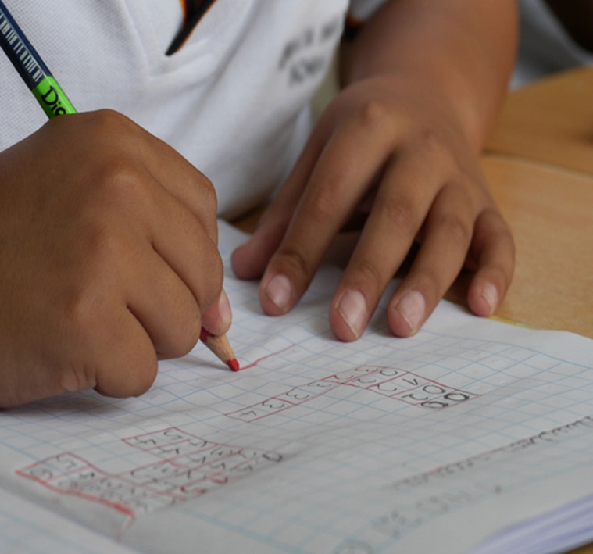

Elaborated based on the Third Cycle and Diversified Education Curriculum for the traditional academic high schools.

**For illustrative purposes only.**

**Sample Rubrics for Self-Study Guides**

|  |  |  |  |
| --- | --- | --- | --- |
| **Eighth Grade. Unit 2 Scenario: Let the Good Times Roll!**  **Assessment Strategy L.2. Recognizes important information from audio texts (e.g., sports announcements, sports scores) provided if the message is delivered clearly.** | | | |
| **Indicators of Learning** | **Achievement level** | | |
| **Not yet achieved**  **1** | **In process**  **2** | **Achieved**  **3** |  |
| L.2.1 Restates orally the topic from audio texts about sports or sports announcements. | Learner cannot restate the topic from audio texts about sports or sports announcements correctly. | Learner can restate part of the topic from audio texts about sports or sports announcements with some difficulty and needs improvement. | Learner can restate the topic from audio texts about sports or sport announcements correctly and with no difficulty. |  |
| L.2.2 Labels illustrations in a conversation or story about sports or sports announcements. | Learner cannot label illustrations in a conversation or story about sports or sports announcements | Learner can label some of the illustrations in a conversations or story about sports or sports announcements with some difficulty and needs improvement. | Learner can label all illustrations in a conversation or story about sports or sports announcements correctly and with no difficulty. |  |
| L.2.3 Gets specific information to complete sentences with key words about sports | Learner cannot get any specific information to complete sentences with keywords about sports correctly. | Learner can get some specific information to complete sentences with keywords about sports with some difficulty and needs improvement. | Learner can get all the specific information to complete sentences with keywords about sports |  |
| L.2.4 Lists important information in a conversation or story about sports or sports announcements. | Learner cannot list information in a conversation or story about sports or sports announcements correctly. | Learner can list some important information in a conversation or story about sports or sports announcements with some difficulty and needs improvement. | Learner can list important information in a conversation or story about sports or sports announcements correctly and with no difficulty. |  |

Propuesta elaborada por: Marianella Granados Sirias, Alfredo Ortega Cordero Asesores Nacionales de Inglés. **Departamento de Tercer Ciclo y Educación Diversificada. Dirección de Desarrollo Curricular** con colaboración de Sandra Araya Acuña, Juan Solano Navarro. Asesores Regionales de Inglés.

|  |  |  |  |
| --- | --- | --- | --- |
| **Eighth Grade. Unit 2 Scenario: Let the Good Times Roll!**  **Assessment Strategy R.4. Recognizes most of what occurs in a well-structured short story and the story’s main characters.** | | | |
| **Indicators of Learning** | **Achievement level** | | |
| **Not yet achieved**  **1** | **In process**  **2** | **Achieved**  **3** |  |
| R4.1 identifies setting in a well-structured short story. | Learner cannot identify the setting in a well-structured short story correctly. | Learner can identify the setting in a well-structured short story with some difficulty and needs improvement. | Learner can identify the setting in a well-structured short story correctly and with no difficulty. |  |
| R4.2.1* names characters in a well-structured short story. | Learner cannot name characters in a well-structured short story. | Learner can name some characters in a well-structured short story with some difficulty and needs improvement. | Learner can describe all the characters in a well-structured short story correctly and with no difficulty. |  |
| R4.2.2* describes characters in a well-structured short story. | Learner cannot describe characters in a well-structured short story. | Learner can describe some characters in a well-structured short story with some difficulty and needs improvement. | Learner can describe characters in a well-structured short story correctly and with no difficulty. |  |
| R4.3 identifies main conflict/problem in a well-structured short story. | Learner cannot identify the main conflict/problem in a well-structured short story correctly. | Learner can identify the main conflict/problem in a well-structured short story with some difficulty and needs improvement. | Learner can identify the main conflict/problem in a well-structured short story correctly and with no difficulty. |  |
| R4.4.1* recounts some of the characters’ efforts in a well-structured short story. | Learner cannot recount the characters’ efforts in a well-structured short story correctly. | Learner can recount some of the characters’ efforts in a well-structured short story with some difficulty and needs improvement. | Learner can recount some of the characters’ efforts in a well-structured short story correctly and with no difficulty. |  |
| R4.4.2 * recounts some of the characters’ obstacles in a well-structured short story. | Learner cannot recount some of the obstacles in a well-structured short story correctly. | Learner can recount some of the obstacles in a well-structured short story with some difficulty and needs improvement. | Learner can recount some of the obstacles in a well-structured short story correctly and with no difficulty. |  |
| R4.5 summarizes the ending in a well-structured short story. | Learner cannot summarize the ending in a well-structured short story correctly. | Learner can summarize the ending in a well-structured short story with some difficulty and needs improvement. | Learner can summarize the ending in a well-structured short story correctly and with no difficulty. |  |

* Notice that indicators R.4.2.1 and R.4.2.2 are subdivided from R.4.2, same case with R.4.4.1 and R.4.4.2.

Propuesta elaborada por: Marianella Granados Sirias, Alfredo Ortega Cordero Asesores Nacionales de Inglés. **Departamento de Tercer Ciclo y Educación Diversificada. Dirección de Desarrollo Curricular** con colaboración de Sandra Araya Acuña, Juan Solano Navarro. Asesores Regionales de Inglés.

|  |  |  |  |
| --- | --- | --- | --- |
| **Eighth Grade. Unit 1 Scenario: My High School…Our place.**  **Assessment Strategy SI.1. Expresses common interests about school life.** | | | |
| **Indicators of Learning** | **Achievement level** | | |
| **Not yet achieved**  **1** | **In process**  **2** | **Achieved**  **3** |  |
| SI1.1 Selects the language and content to express common interests about school life. For example: My favorite is.., I don’t like … | Learner cannot select the language and content to express common interests about school life. For example: My favorite is.., I don’t like… correctly. | Learner can select part of the language and content to express common interests about school life. For example: My favorite is.., I don’t like… with some difficulty and needs improvement. | Learner can select all the language and content to express common interests about school life. For example: My favorite is.., I don’t like… correctly with no difficulty. |  |
| SI1. 2 Elaborates sentences to express common interests about school life. | Learner cannot elaborate sentences to express common interests about school life correctly. | Learner can elaborate some sentences to express common interests about school life with some difficulty and needs improvement. | Learner can elaborate sentences to express common interests about school life correctly with no difficulty. |  |
| SI1. 3 Expresses common interests about school life. | Learner cannot express common interests about school life correctly. | Learner can express some common interests about school life with some difficulty and needs improvement. | Learner can express common interests about school life correctly with no difficulty. |  |
| SI 1.4 Asks questions about others’ schedules. | Learner cannot ask questions about others´ schedules correctly. | Learner can ask some questions about others´ schedules with some difficulty and needs improvement. | Learner can ask questions about others´ schedules correctly with no difficulty. |  |
| SI 1.5 Answers questions about their own schedules. | Learner cannot answer questions about their own schedules correctly. | Learner can answer some questions about their own schedules with some difficulty and needs improvement. | Learner can answer questions about their own schedules correctly with no difficulty. |  |
| Maintains appropriate communication strategies while answering the questions stated (uses of facial expressions and gestures, asks for repetition, indicates lack of understanding, repeats words. | Learner cannot maintain communication most of the time. Hard for him/her to use the communication strategies to overcome difficulties correctly. | Learner can make correct use of some of the communication strategies to maintain communication going with some difficulty, but not all the time and inconsistently. Learner needs improvement. | Learner can make use of many communication strategies to maintain communication going, which helps to keep the flow of the conversation correctly with no difficulty. |  |
| Pronounces the target language in the answers provided correctly | Learner makes constant mistakes in pronunciation during his/her answers. (More than 4 mistakes) | Learner´s pronunciation is understandable at most times. Occasional mispronunciation; some consistent mistakes in his/her answers. (3-4 mistakes) | Learner has clear and smooth pronunciation in his/her answers at this level. Few sporadic deviations. (1-2 mistakes) |  |
| Stresses words and uses appropriate intonation in sentences or answers provided correctly. | Learner cannot stress individual words correctly and use appropriate intonation when forming sentences. | Learner can stress some individual words correctly and use appropriate intonation when answering with some difficulty and needs improvement. | Learner can constantly stress individual words correctly and use appropriate intonation when answering with no difficulty. |  |
| Speaks at a normal speed during the period of the interaction (question/answer task) | Learner carries out the task with hesitation that interferes with the message. Some long pauses to recall meaning. | Learner can carry out the task adequately with some hesitation that seldom interferes with the message. Few short pauses to recall meaning. | Learner can carry out the task with confidence. Very sporadic short pauses to recall meaning. |  |
| Uses the appropriate register and politeness conventions according to the given context and task. (Sociolinguistic Appropriateness) | Learner cannot use the appropriate register (formal or informal) for the task given. Expressions and word choice are contextually inappropriate in terms of manners, politeness and tactfulness. | Learner can partially use one register (formal or informal) without considering the task given. Expressions and word choice are sometimes contextually appropriate in terms of manners, politeness and tactfulness. Learner needs improvement. | Learner can fully use the appropriate register (formal or informal) at all times depending on the task and context given. Expressions and word choice are always contextually appropriate in terms of manners and politeness. |  |

**\* Notice that the assessment strategy, that includes indicators for asking and answering, must be separated subdividing the indicator. Besides, the indicators in green were constructed to measure overall achievement in aspects related to pronunciation, fluency and sociolinguistic appropriateness**. **They must be present in all instruments related to Spoken Interaction, Spoken production and Written as required.**

Propuesta elaborada por: Marianella Granados Sirias, Alfredo Ortega Cordero Asesores Nacionales de Inglés. **Departamento de Tercer Ciclo y Educación Diversificada. Dirección de Desarrollo Curricular** con colaboración de Sandra Araya Acuña, Juan Solano Navarro. Asesores Regionales de Inglés.

|  |  |  |  |
| --- | --- | --- | --- |
| **Eighth Grade. Unit 3 Scenario: Something to celebrate.**  **Assessment Strategy SI.2 asks and answers about holidays and festivals in Latin America and around the world. \*** | | | |
| **Indicators of Learning** | **Achievement level** | | |
| **Not yet achieved**  **1** | **In process**  **2** | **Achieved**  **3** |  |
| SI.2.2 Asks questions about local holidays, celebrations and festivals in Latin America and around the world | Learner cannot ask questions about local holidays, celebrations and festivals in Latin America and around the world correctly. | Learner can partially ask questions about local holidays, celebrations and festivals in Latin America and around the World with some difficulty and needs improvement. | Learner can fully ask questions about local holidays, celebrations and festivals in Latin America and around the world. |  |
| SI.2.4. Answers questions about local holidays, celebrations and festivals in Latin America and around the world. | Learner cannot answer questions about local holidays, celebrations and festivals in Latin America and around the world correctly. | Learner can partially answer questions about local holidays, celebrations and festivals in Latin America and around the world with some difficulty and needs improvement. | Learner can fully answer questions about local holidays, celebrations and festivals in Latin America and around the world correctly with no difficulty. |  |
| Maintains appropriate communication strategies while answering the questions stated (uses of facial expressions and gestures, asks for repetition, indicates lack of understanding, repeats words. | Learner cannot maintain communication most of the time. Hard for him/her to use the communication strategies to overcome difficulties correctly. | Learner can make correct use of some of the communication strategies to maintain communication going with some difficulty, but not all the time and inconsistently. Learner needs improvement. | Learner can make use of many communication strategies to maintain communication going, which helps to keep the flow of the conversation correctly with no difficulty. |  |
| Pronounces the target language in the answers provided correctly | Learner makes constant mistakes in pronunciation during his/her answers. (More than 4 mistakes) | Learner´s pronunciation is understandable at most times. Occasional mispronunciation; some consistent mistakes in his/her answers. (3-4 mistakes) | Learner has clear and smooth pronunciation in his/her answers at this level. Few sporadic deviations. (1-2 mistakes) |  |
| Stresses words and uses appropriate intonation in sentences or answers provided correctly. | Learner cannot stress individual words correctly and use appropriate intonation when forming sentences. | Learner can stress some individual words correctly and use appropriate intonation when answering with some difficulty and needs improvement. | Learner can constantly stress individual words correctly and use appropriate intonation when answering with no difficulty. |  |
| Speaks at a normal speed during the period of the interaction (question/answer task) | Learner carries out the task with hesitation that interferes with the message. Some long pauses to recall meaning. | Learner can carry out the task adequately with some hesitation that seldom interferes with the message. Few short pauses to recall meaning. | Learner can carry out the task with confidence. Very sporadic short pauses to recall meaning. |  |
| Uses the appropriate register and politeness conventions according to the given context and task. (Sociolinguistic Appropriateness) | Learner cannot use the appropriate register (formal or informal) for the task given. Expressions and word choice are contextually inappropriate in terms of manners, politeness and tactfulness. | Learner can partially use one register (formal or informal) without considering the task given. Expressions and word choice are sometimes contextually appropriate in terms of manners, politeness and tactfulness. Learner needs improvement. | Learner can fully use the appropriate register (formal or informal) at all times depending on the task and context given. Expressions and word choice are always contextually appropriate in terms of manners and politeness. |  |

**\* Notice that the assessment strategy, that includes indicators for asking and answering, must be separated subdividing the indicator. Besides, the indicators in green were constructed to measure overall achievement in aspects related to pronunciation, fluency and sociolinguistic appropriateness**. **They must be present in all instruments related to Spoken Interaction, Spoken production and Written Production as required.**

Propuesta elaborada por: Marianella Granados Sirias, Alfredo Ortega Cordero Asesores Nacionales de Inglés. **Departamento de Tercer Ciclo y Educación Diversificada. Dirección de Desarrollo Curricular** con colaboración de Sandra Araya Acuña, Juan Solano Navarro. Asesores Regionales de Inglés.

|  |  |  |  |
| --- | --- | --- | --- |
| **Eighth Grade. Unit 3 Scenario: Something to celebrate.**  **Assessment Strategy SP.2 describes what he/she did on his /her last holiday.** | | | |
| **Indicators of Learning** | **Achievement level** | | |
| **Not yet achieved**  **1** | **In process**  **2** | **Achieved**  **3** |
| SP2.1 Notes down the appropriate information to describe the last holiday. | Learner cannot note down the appropriate information to describe the last holiday. | Learner can partially note down the appropriate information to describe the last holiday with some difficulty and needs improvement. | Learner can fully note down the appropriate information to describe the last holiday correctly with no difficulty. |
| SP2.2 Organizes the information and resources to describe the last holiday. | Learner cannot organize the information and resources to describe the last holiday  correctly. | Learner can partially organize the information and resources to describe the last holiday with some difficulty and needs improvement. | Learner can fully organize the information and resources to describe the last holiday correctly with no difficulty. |
| SP2.3 Makes sentences about the last holiday. | Learner cannot make sentences about the last holiday correctly. | Learner can partially make sentences about the last holiday with some difficulty and needs improvement. | Learner can fully make sentences about the last holiday correctly with no difficulty. |
| SP2.4 Describes the last holiday using sequential past time. | Learner cannot describe the last holiday using sequential past time: first, then, after that, finally correctly. | Learner can partially describe the last holiday, but does not use sequential past time: first, then, after that, finally with some difficulty and needs improvement. | Learner can fully describe the last holiday using sequential: past time first, then, after that, finally correctly with no difficulty. |
| Maintains appropriate  communication strategies to describe holidays (uses of facial expressions and gestures,   asks for repetition, indicates lack of understanding, repeats words). | Learner cannot maintain communication most of the time. Hard for him/her to use the communication strategies to overcome difficulties correctly. | Learner can make correct use of some of the communication strategies to maintain communication going with some difficulty, but not all the time and inconsistently. Learner needs improvement. | Learner can make use of many communication strategies to maintain communication going, which helps to keep the flow of the conversation correctly with no difficulty. |
| Pronounces the target language  about holidays correctly. | Learner makes constant mistakes in pronunciation. (More than 4 mistakes) | Learner pronunciation is understandable at most times. Occasional mispronunciation; some consistent mistakes. (3-4 mistakes) | Learner has clear and smooth pronunciation at this level. Few sporadic deviations. (1-2 mistakes) |
| SP.2.4.3 Stresses words and use appropriate intonation in sentences correctly. | Learner cannot stress individual words correctly and does not use appropriate intonation when making sentences. | Learner can stress individual words correctly and use appropriate intonation when making sentences with some difficulty and needs improvement. | Learner can constantly stress individual words correctly and use appropriate intonation when making sentences with no difficulty. |
| SP.2.4.4 Speaks at a normal speed during the production task | Learner carries out the task with hesitation that interferes with the message. Some long pauses to recall meaning. | Learner can carry out the task adequately with some hesitation that seldom interferes with the message. Few short pauses to recall meaning. | Learner can carry out the task with confidence. Very sporadic short pauses to recall meaning. |
| SP.2.4.5 Uses the appropriate register and politeness conventions according to the given context and task. (Sociolinguistic Appropriateness) | Learner cannot use the appropriate register (formal or informal) for the task given. Expressions and word choice are contextually inappropriate in terms of manners, politeness and tactfulness. | Learner can partially use one register (formal or informal) without considering the context given. Expressions and word choice are sometimes contextually appropriate in terms of manners, politeness and tactfulness. Learner needs improvement. | Learner can fully use the appropriate register (formal or informal) at all times depending on the task and context given. Expressions and word choice are always contextually appropriate in terms of manners and politeness. |

**\* The indicators in green were constructed to measure overall achievement in aspects related to pronunciation, fluency and sociolinguistic appropriateness**. **They must be present in all instruments related to Spoken Interaction, Spoken production and Written Production** as required.

Propuesta elaborada por: Marianella Granados Sirias, Alfredo Ortega Cordero Asesores Nacionales de Inglés. **Departamento de Tercer Ciclo y Educación Diversificada. Dirección de Desarrollo Curricular** con colaboración de Sandra Araya Acuña, Juan Solano Navarro. Asesores Regionales de Inglés.

|  |  |  |  |
| --- | --- | --- | --- |
| **Eighth Grade Unit 1 Scenario: My High School…Our place**  **Assessment Strategy: W.2. Writes an explanation of what they do every day at school, with the help of illustrations.** | | | |
| **Indicators of Learning** | **Achievement level** | | |
| **Not yet achieved**  **1** | **In process**  **2** | **Achieved**  **3** |
| **W2.1** Drafts an explanation with illustrations about activities in a typical day at school, and a conclusion | Learner cannot draft an explanation with illustrations about a typical day at school, and a conclusion correctly. | Learner can partially draft an explanation with illustrations about a typical day at school, and a conclusion with some difficulty and needs improvement. | Learner can fully draft an explanation with illustrations about a typical day at school, and a conclusion correctly and with no difficulty. |
| **W2.2** Revises the explanation about a typical day at school. | Learner cannot revise the explanation about a typical day at school correctly. | Learner can partially revise the explanation about a typical day at school with some difficulty and needs improvement. | Learner can fully revise the explanation about a typical day at school correctly and with no difficulty. |
| **W2.2.1 * Checks** written sentences to look for mistakes related to subject-verb agreement, capitalization, spelling, and basic punctuation). | Learner cannot check the written sentences presenting constant subject verb agreement, capitalization, spelling, and punctuation mistakes. | Learner can partially check the written sentences and some subject verb agreement, capitalization, spelling, and punctuation mistakes. | Learner can fully check the written sentences avoiding subject verb agreement, capitalization, spelling, and punctuation mistakes. |
| W2.2.2*Arranges Linking words, groups of words, sentences, paragraphs, and texts in a well-organized and logical manner. (Coherence and Cohesion) | Learner‘s production cannot show sense of coherence & cohesion. No sense in the organization of its content and use of discourse markers. | Learners' production can partially show a sense through the organization of its content and use of discourse markers. | Learner's production can fully show reasonable sense through the organization of its content and use of discourse markers. |
| W2.2.3* Uses the appropriate register and politeness conventions according to the given context. (Sociolinguistic Appropriateness | Learner cannot use the appropriate register (formal or informal) for the task given. Expressions and word choice are contextually inappropriate in terms of manners, politeness and tactfulness. | Learner can partially use one register (formal or informal) without considering the context given. Expressions and word choice are sometimes contextually appropriate in terms of manners, politeness and tactfulness. Learner needs improvement. | Learner can fully use the appropriate register (formal or informal) at all times depending on the task and context given. Expressions and word choice are always contextually appropriate in terms of manners and politeness. |
| **W2.3** Edits the explanation by correcting the mistakes before publishing it. | Learner cannot edit the explanation by correcting the mistakes before publishing it correctly. | Learner can partially edit the explanation by correcting the mistakes before publishing it with some difficulty and needs improvement. | Learner can fully edit the explanation by correcting the mistakes before publishing it correctly and with no difficulty. |
| Links words, groups of words, sentences, paragraphs, and texts in a well-organized and logical manner. (Coherence and Cohesion) | Learner‘s production cannot show sense of coherence & cohesion. No sense in the organization of its content and use of discourse markers. | Learners' production can partially show a limited sense through the organization of its content and use of discourse markers. | Learner's production can fully show reasonable sense through the organization of its content and use of discourse markers. |
| Uses the appropriate register and politeness conventions according to the given context. (Sociolinguistic Appropriateness | Learner cannot use the appropriate register (formal or informal) for the task given. Expressions and word choice are contextually inappropriate in terms of manners, politeness and tactfulness. | Learner can partially use one register (formal or informal) without considering the context given. Expressions and word choice are sometimes contextually appropriate in terms of manners, politeness and tactfulness. Learner needs improvement. | Learner can fully use the appropriate register (formal or informal) at all times depending on the task and context given. Expressions and word choice are always contextually appropriate in terms of manners and politeness. |

* Notice that Indicator W2.2.1 comes from Indicator W2.2, and that W2.2.1, W2.2.2, and W2.2.3 are subdivided from Indicator W2.2. The indicators in green were constructed to measure overall achievement in aspects related to pronunciation, fluency and sociolinguistic appropriateness. They must be present in all instruments related to Spoken Interaction, Spoken production and Written Production as required.

Propuesta elaborada por: Marianella Granados Sirias, Alfredo Ortega Cordero Asesores Nacionales de Inglés. Departamento de Tercer Ciclo y Educación Diversificada. Dirección de Desarrollo Curricular con colaboración de Sandra Araya Acuña, Juan Solano Navarro. Asesores Regionales de Inglés.

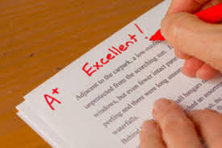

Sample Rubrics and Performance Scale for Summative Assessment Instruments and the Assessment Promotion Strategy

|  |  |  |  |  |  |
| --- | --- | --- | --- | --- | --- |
| **Analytic Rubric**  High School:___________________                                 Score:_____________  Summative instrument                                                                  Total Points:  ________  Allotted Time: ____________minutes       Gotten points: _______  Level: Eighth Grade Percentage: __________%  Teacher: __________________________          Obtained Percentage: ____________  Date: _____________________________  Student`s name:____________________________________                         Group:___________ | | | | | |
| **Scenario** | Let the Good Times Roll! | | | | |
| **Assessment Strategy** | R.4 Recognizes most of what occurs in a well-structured short story and the story´s main characters. | | | | |
| **Task** | Today is your birthday. Your best friend gave you a book with different short stories as a present. From the book, read the short story “A day I’ll never forget” and work on the following guide to make a summary for your mother.   * + - 1. Identify the setting of the story.       2. Name all characters in the story.       3. Describe each character of the story.       4. Identify the main conflict/problem of the story.       5. Recount some of the characters´ efforts.       6. Recount some of the characters´ obstacles.       7. Summarize the ending of the story. | | | | |
| **Indicator of Learning** | | **N/A**  **0** | **Achievement level** | | |
| **Not yet achieved**  **1** | **In process**  **2** | **Achieved**  **3** |
| R4.1 identifies setting in a well-structured short story. | |  | Learner cannot identify the setting in a well-structured short story correctly. | Learner can partially identify the setting in a well-structured short story with some difficulty and needs improvement. | Learner can fully identify the setting in a well-structured short story correctly and with no difficulty. |
| R4.2 names characters in a well-structured short story. | |  | Learner cannot name characters in a well-structured short story. | Learner can name some characters in a well-structured short story with some difficulty and needs improvement. | Learner can name all the characters in a well-structured short story correctly and with no difficulty. |
| R4.2 describes characters in a well-structured short story. | |  | Learner cannot describe characters in a well-structured short story. | Learner can partially describe some characters in a well-structured short story with some difficulty and needs improvement. | Learner can fully describe all the characters in a well-structured short story correctly and with no difficulty. |
| R4.3 identifies main conflict/problem in a well-structured short story. | |  | Learner cannot identify the main conflict/problem in a well-structured short story correctly. | Learner can partially identify the main conflict/problem in a well-structured short story with some difficulty and needs improvement. | Learner can fully identify the main conflict/problem in a well-structured short story correctly and with no difficulty. |
| R4.4 recounts some of the characters’ efforts in a well-structured short story. | |  | Learner cannot recount some of the characters’ efforts in a well-structured short story correctly. | Learner can partially recount some of the characters’ efforts in a well-structured short story with some difficulty and needs improvement. | Learner can fully recount all of the characters’ efforts in a well-structured short story correctly and with no difficulty. |
| R4.4 recounts some of the characters’ obstacles in a well-structured short story. | |  | Learner cannot recount some of the obstacles in a well-structured short story correctly. | Learner can partially recount some of the obstacles in a well-structured short story with some difficulty and needs improvement. | Learner can fully recount all of the obstacles in a well-structured short story correctly and with no difficulty. |
| R4.5 summarizes the ending in a well-structured short story. | |  | Learner cannot summarize the ending in a well-structured short story correctly. | Learner can partially summarize the ending in a well-structured short story with some difficulty and needs improvement. | Learner can fully summarize the ending in a well-structured short story correctly and with no difficulty. |

Propuesta elaborada por: Sandra Araya Acuña, Juan Solano Navarro. Asesores Regionales de Inglés y validada por Marianella Granados Sirias, Alfredo Ortega Cordero Asesores Nacionales de Inglés. Departamento de Tercer Ciclo y Educación Diversificada. Dirección de Desarrollo Curricular.

|  |  |  |  |  |  |  |  |
| --- | --- | --- | --- | --- | --- | --- | --- |
| **Oral Performance Scale-Sample (Oral Production)**  **Dos Cercas High School                                        Score:_____________**  **Summative instrument                                                                  Total Points:  ________**  **Allotted Time: ____________minutes       Gotten points: _______**  **Level: Eighth Grade Percentage: __________%**  **Teacher: __________________________          Obtained Percentage: ____________**  **Date: _____________________________**  **Student`s name:____________________________________                         Group:___________** | | | | | | | |
| **Scenario:** | | **Something to Celebrate!** | | | | | |
| **Assessment Strategy** | | **SI.2.** Asks and answers about holidays and festivals in Costa Rica, Latin America and around the World. | | | | | |
| **Description of linguistic task** | | **Information exchange (2 minutes)**  You are participating in an international school summer camp. You were asked to talk about favorite holidays or celebrations around the world. Choose one and talk about when and where it is celebrated, special food, activities. Use pictures to talk about it and ask questions to the teacher or classmates. Answer a couple of questions from your teacher or classmates. | | | | | |
| **Indicators\*** | **Points per indicator** | |  | | | | |
| **N/A**  **0** | **1** | **2** | **3** | **4** |
| **Asks questions about holidays and festivals in Costa Rica, Latin America and around the World.** | 3 | |  | Asks questions about holidays and festivals in Costa Rica, Latin America and around the World with a lot of difficulty. The student fails to ask for most of the information (He/she cannot control memorized language structures (question patterns), so it is hard to be understood. | Asks questions about holidays and festivals in Costa Rica, Latin America and around the World appropriately sometimes. The student asks information about some of the elements.  He/she can partially control memorized language structures                (question patterns), to be somehow understood. | Asks questions about holidays and festivals in Costa Rica, Latin America and around the World appropriately and with ease. The student gets to ask for information about all the elements. He/she can consistently control basic language structures (question patterns) |  |
| **Answers questions about holidays and festivals in Costa Rica, Latin America and around the World.** | 4 | |  | Answers were incomplete He/she hardly answers questions about holidays and festivals in Costa Rica, Latin America and around the World appropriately when asked.  He/she cannot identify the question word and helping verb to provide an answer with control of memorized language structures (sentence patterns), so it is hard to be understood. | Answers were partially accomplished. He/she sometimes answers questions about holidays and festivals in Costa Rica, Latin America and around the World appropriately when asked. He/she can partially identify the question word and helping verb to provide an answer with control of memorized language structures (sentence patterns) to be somehow understood. | Answers were accomplished. Most of the time, he/she answers questions about holidays and festivals in Costa Rica, Latin America and around the World appropriately when asked.  He/she can identify question words, helping verb and basic language structures (sentence patterns) at most times. | Answers were successfully accomplished. He/she, at all times, answers questions about holidays and festivals in Costa Rica, Latin America and around the World appropriately when asked.  He/she can consistently identify question words, helping verb and basic language structures (sentence patterns) |
| **Gives information about holidays and festivals in Costa Rica, Latin America and around the World.** | 3 | |  | The task was incomplete He/she hardly gives information about holidays and festivals in Costa Rica, Latin America and around the World. He/she cannot control memorized language structures (sentence patterns), so it is hard to be understood | The task was partially accomplished. He/she somewhat gives information about holidays and festivals in Costa Rica, Latin America and around the World by either talking about the holiday or festival name or date of celebration. He/she can partially control memorized language structures  (sentence pattern), to be somehow understood | The task was successfully accomplished. He/she gives information about holidays and festivals in Costa Rica, Latin America and around the World by talking about when and where they are celebrated, special food, activities.  He/she can consistently control basic language structures (sentence patterns) |  |
| **\*Uses appropriate**  **communication**  **strategies (uses of facial expressions**  **and gestures, asks for repetition, indicates lack of understanding,**  **repeats words).** | 3 | |  | Fails in maintaining communication most of the time. Hard for him/her to use the communication strategies to overcome difficulties. | Makes use of some of the communication strategies to maintain communication going, but not all the time and inconsistently. | Makes use of many communication strategies to maintain communication going, which helps to keep the flow of the conversation | . |
| **\*Pronounces the target language correctly** | 3 | |  | Difficulty at understanding. Constant mistakes in pronunciation  (More than 4 mistakes) | Understandable at most times. Occasional mispronunciation; some consistent mistakes.  (3-4 mistakes) | Clear and smooth pronunciation at this level. Few sporadic deviations.  (1-2 mistakes) |  |
| **\*Stresses words and sentences correctly** | 2 | |  | Sometimes  stresses individual words correctly and uses appropriate intonation when forming sentences | Constantly stresses individual words correctly and uses appropriate intonation when forming sentences |  |  |
| **\*Speaks at a**  **normal speed** | 3 | |  | Carried out with hesitation that sometimes interferes with the message. Some long pauses to recall meaning. | Carried out adequately with some hesitation that seldom interferes with the message. Few short pauses to recall meaning. | Carried out with confidence. Sporadic short pauses to recall meaning. |  |
| **Total:** | 23 | |  |  |  |  |  |
| **Comments:** | | | | | | | |

**\*The indicators related to pronunciation, fluency and sociolinguistic appropriateness were constructed to measure overall achievement**. **They must be present in all instruments related to Spoken Interaction and Spoken production as required.**

Propuesta elaborada por: Marianella Granados Sirias y Alfredo Ortega Cordero. Asesores Nacionales de Inglés. **Departamento de Tercer Ciclo y Educación Diversificada. Dirección de Desarrollo Curricular, 2021.**

**References**

Curriculum Services Canada, A Guide to Reflective Practice for Core French Teachers, The Action-Oriented Approach. Module 3. Ministry of Education and the Government of Canada through the Department of Canadian Heritage.

Common European Framework of Reference for Languages: Learning, Teaching, Assessment (2003). Cambridge, U.K.: Press Syndicate of the University of Cambridge.

Common European Framework of Reference for Languages: Learning, Teaching, Assessment (2018). Cambridge, U.K.: Press Syndicate of the University of Cambridge.

Frade, L. (2009) Desarrollo de Competencias en Educación. Inteligencia Educativa. 2 edición (295-402)

Ministerio de Educación Pública (2021). Lineamientos técnicos para el proceso de evaluación, curso lectivo 2021. San José, Costa Rica: MEP.

Ministerio de Educación Pública (2021). Mediación Pedagógica para la Educación Combinada, curso lectivo 2021. San José, Costa Rica: MEP.

Ministerio de Educación Pública (2016). Programa de Estudio de Inglés Tercer Ciclo y Educación Diversificada Académico. San José, Costa Rica: MEP.

Ministerio de Educación Pública (2017). Programa de Estudio de Inglés Plan de Estudios Liceo Bilingüe Secciones Bilingües español –Inglés Tercer Ciclo. San José, Costa Rica: MEP.

Ministerio de Educación Pública (2020). Programa de Estudio de Inglés Plan de Estudios Liceo Bilingüe Secciones Bilingües español –Inglés Educación Diversificada. San José, Costa Rica: MEP.

<https://www.orientacionandujar.es/2016/11/06/taxonomia-robert-marzano-verbos-recomendados-indicadores-niveles-cognitivos/>